11.02 Parallel lines and transversals
Year 7 Maths · Worksheet · Level 3 · Challenge
Name: ____________________ Date: ______________
This worksheet practises multi-step angle problems on parallel lines, explaining why the angle rules work and deciding whether lines are parallel. Tip: if you are stuck, draw an extra line parallel to the others through a corner. It often turns a hard problem into two easy ones.

 Understanding
- The eight angles in this diagram are labelled $a$ to $h$.
- 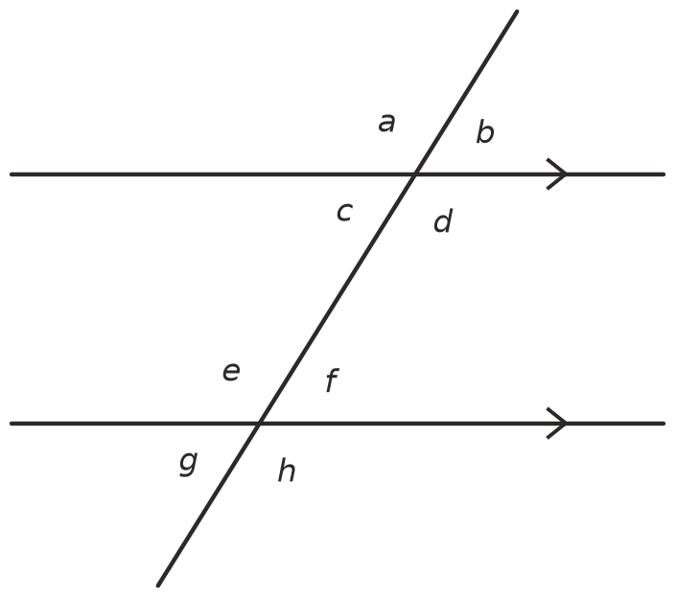
- Complete the table. If a pair is not corresponding, alternate, co-interior or vertically opposite, write “none”.
Pair of angles | Type of pair | Equal, or add to 180°?
$c$ and $f$
$b$ and $c$
$d$ and $h$
$c$ and $e$
$a$ and $f$
$b$ and $g$

- AB is parallel to CD.
- 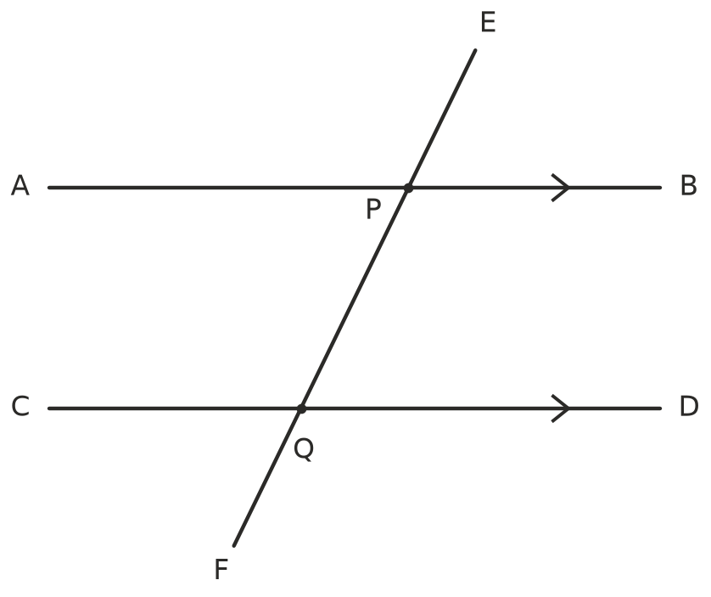
  - Which angle is alternate to ∠APQ? ______________
  - Which angle is corresponding to ∠APE? ______________
  - Which angle is co-interior with ∠BPQ? ______________
  - ∠EPB = 64°. Find ∠CQP and ∠CQF. ______________

 Fluency
- Find the value of each pronumeral. Give a reason for each step.
- 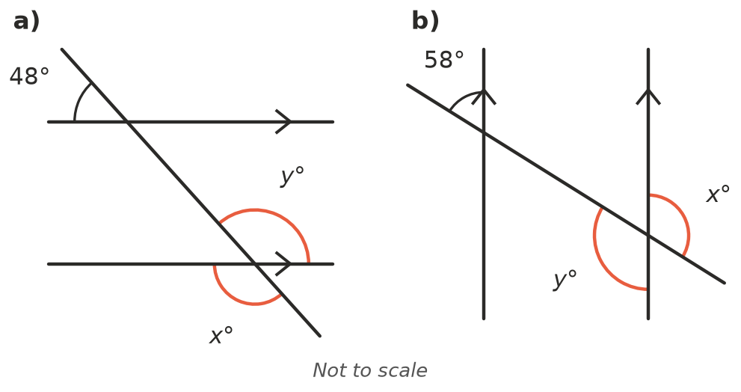
  - $x$ = ______________ $y$ = ______________ Reasons: ______________
  - $x$ = ______________ $y$ = ______________ Reasons: ______________
- 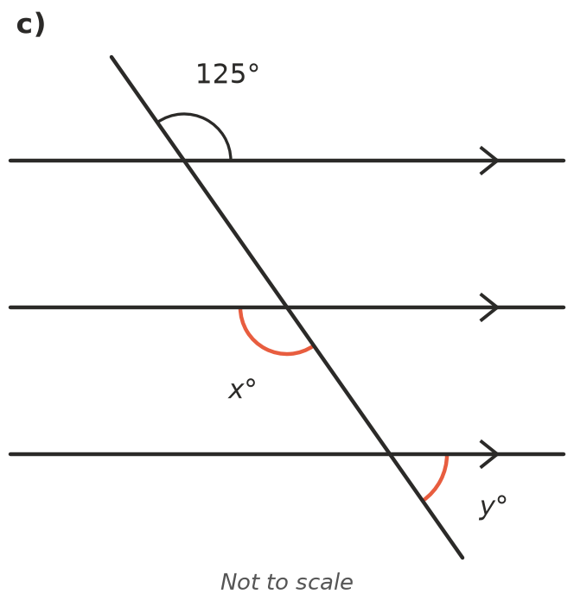
  - $x$ = ______________ $y$ = ______________ Reasons: ______________
- Find $x$. Hint: draw a line through the corner, parallel to the other two lines.
- 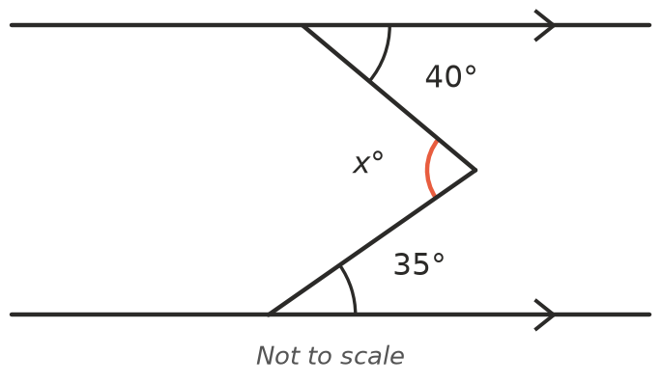

- $x$ = ______________
- Each pair of angles is on parallel lines. Write an equation and solve it to find $x$. Then find the size of each angle.
  - Co-interior angles: (2$x$ + 10)° and (3$x$ − 5)° ______________
  - Alternate angles: 4$x$° and ($x$ + 60)° ______________
  - Corresponding angles: (5$x$ − 20)° and (3$x$ + 30)° ______________

 Reasoning
- Use corresponding angles and vertically opposite angles to explain why alternate angles on parallel lines are equal. Draw a labelled sketch.

- Is AB parallel to CD? Explain your reasoning.
- 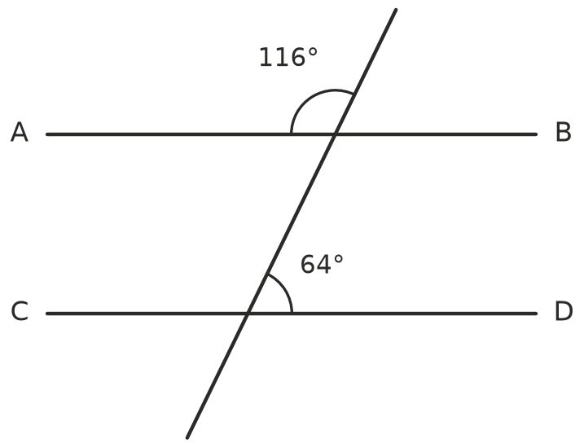

- Liam looked at this diagram and said, “100 + 80 = 180, so AB is parallel to CD.” Explain Liam’s mistake.
- 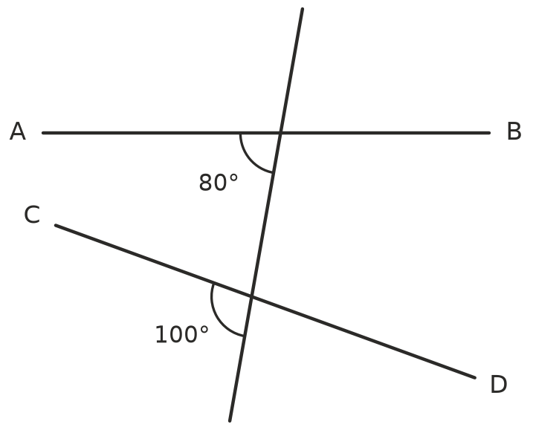

- In Question 4, suppose the two angles at the parallel lines are $a$° and $b$° instead of 40° and 35°. Write a rule for $x$ and explain why it works.

 Problem solving
- Find $x$. Show your working. Hint: draw a third parallel line through the corner.
- 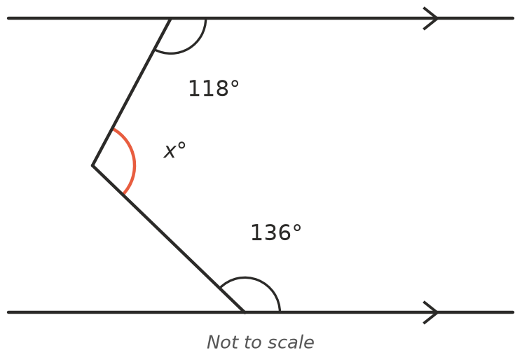

- $x$ = ______________
- The sides of a parallelogram make two pairs of parallel lines. Two neighbouring angles of the parallelogram are (3$x$ + 15)° and (2$x$ + 15)°. Find $x$ and all four angles.

- Two parallel lines are crossed by a transversal. One of the eight angles is four times as big as another of the angles. Find the sizes of all eight angles.

