11.02 Parallel lines and transversals
Year 7 Maths · Worksheet · Level 1 · Warm-up
Name: ____________________ Date: ______________
This worksheet practises the three angle pairs you get when a line crosses two parallel lines. Tip: corresponding angles make an F shape and are equal, alternate angles make a Z shape and are equal, and co-interior angles make a C shape and add to 180°. Arrows on lines show that they are parallel.

 Understanding
- Look at the diagram.
- 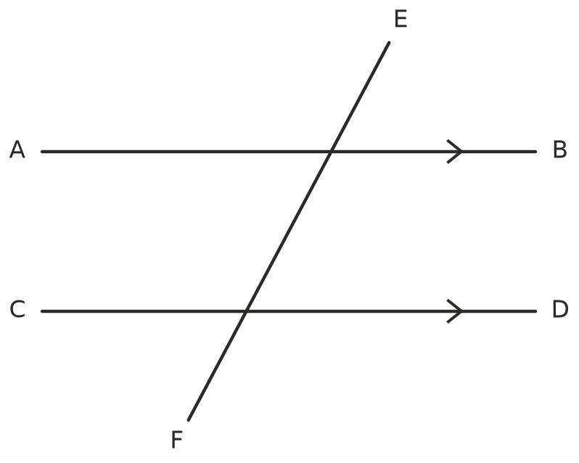
  - Which two lines are parallel? How can you tell? ______________
  - A line that crosses two or more other lines is called a transversal. Which line is the transversal? ______________
- The eight angles in this diagram are labelled $a$ to $h$.
- 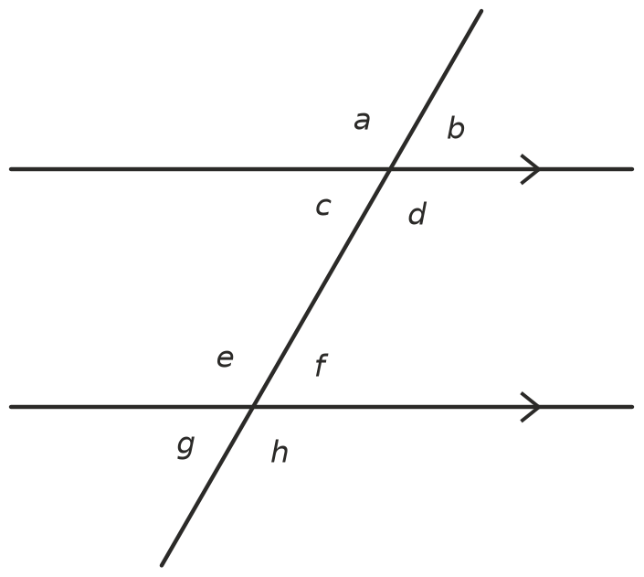
- For each pair of angles, write corresponding, alternate or co-interior.
Pair of angles | Type of pair
$a$ and $e$
$c$ and $f$
$d$ and $f$
$b$ and $f$
$d$ and $e$
$c$ and $e$

- Complete each sentence about angles on parallel lines.
  - Corresponding angles are ______________
  - Alternate angles are ______________
  - Co-interior angles add to ______________

 Fluency
- Find the value of $x$. Write the type of angle pair as your reason.
- 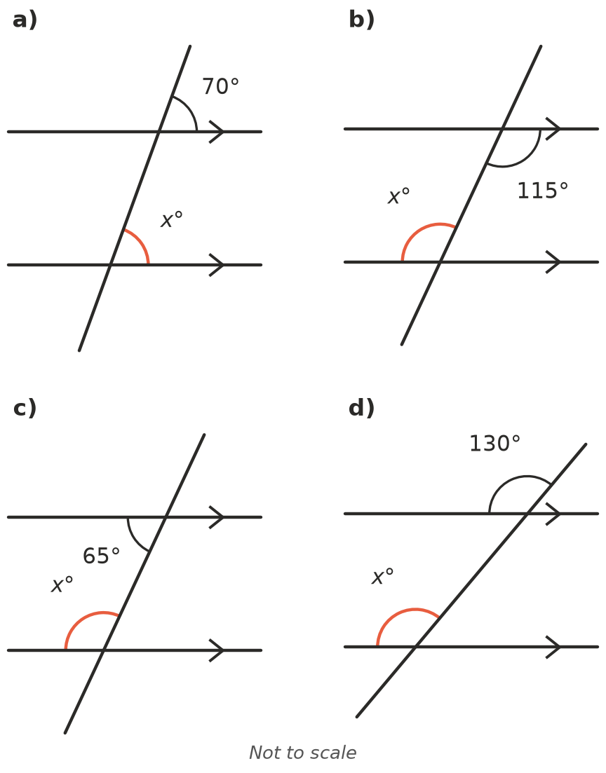
  - $x$ = ______________ Reason: ______________
  - $x$ = ______________ Reason: ______________
  - $x$ = ______________ Reason: ______________
  - $x$ = ______________ Reason: ______________
- In the diagram in Question 2, angle $b$ = 60°. Find the size of every other angle.
$a$ | $c$ | $d$ | $e$ | $f$ | $g$ | $h$

 Reasoning
- These lines have no arrows. Decide whether each pair of lines is parallel. Explain how you know.
- 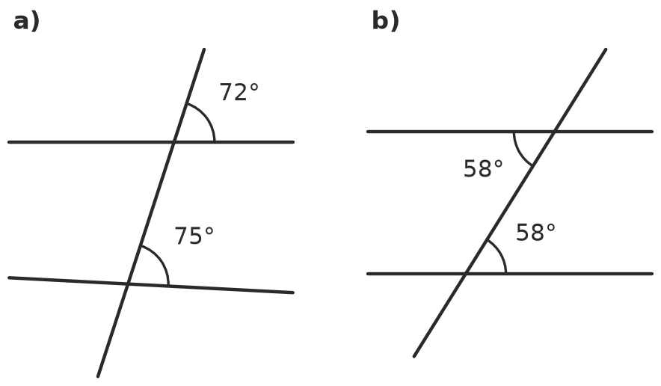
  - ______________
  - ______________
- Tom says, “Co-interior angles are always equal.” Explain why Tom is wrong. Give an example.

 Problem solving
- A farm gate has a top rail and a bottom rail that are parallel. A diagonal brace makes an angle of 40° with the bottom rail. Find $x$, the angle the brace makes with the top rail. What type of angle pair is this?
- 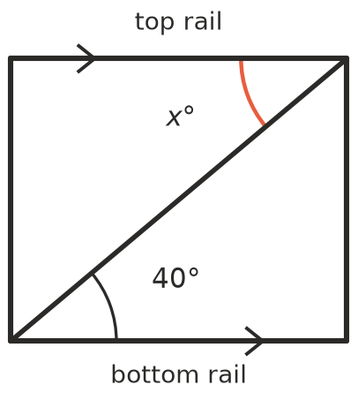
- $x$ = ______________ Reason: ______________
- Beach Rd and Bay St are parallel. A straight road crosses both of them. Find $x$.
- 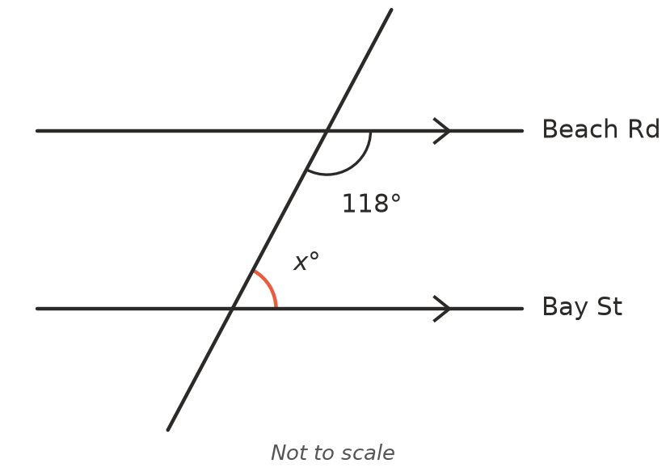
- $x$ = ______________ Reason: ______________
- Find $x$ and then $y$. Give a reason for each step.
- 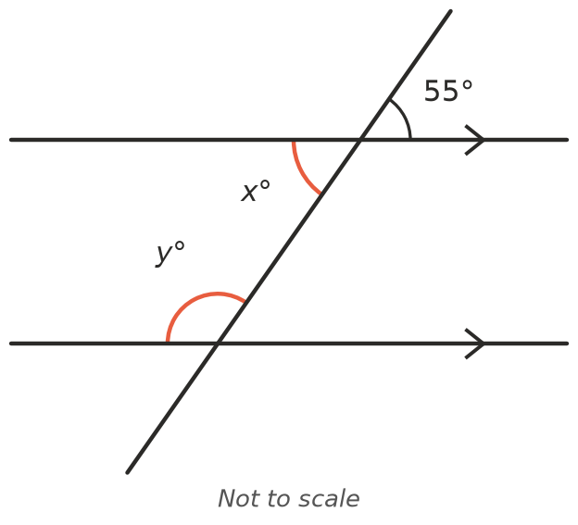
- $x$ = ______________ Reason: ______________
- $y$ = ______________ Reason: ______________
- Is each statement true or false? Write True or False in each empty box.
Statement | True or false
A transversal crosses two or more lines.
Alternate angles are on the same side of the transversal.
If corresponding angles are equal, the lines are parallel.
Co-interior angles lie between the two parallel lines.

