11.02 Parallel lines and transversals
Year 7 Maths · A5 question sheet · Level 2 · Core
This worksheet practises finding angles on parallel lines and giving reasons. Tip: when parallel lines are crossed by a transversal, every angle is one of only two sizes, and those two sizes add to 180°. Always name the angle pair you used: corresponding, alternate, co-interior or vertically opposite.

 Understanding
- The eight angles in this diagram are labelled $a$ to $h$.
- 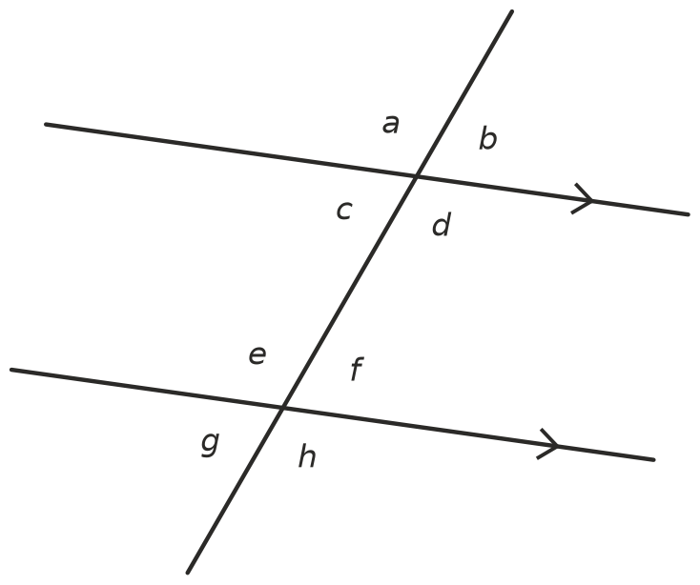
- Name each pair: corresponding, alternate, co-interior or vertically opposite.
Pair of angles
$a$ and $d$
$b$ and $f$
$d$ and $e$
$c$ and $e$
$h$ and $d$
$f$ and $c$

- Use the diagram in Question 1. Which angle is:
  - alternate to $d$?
  - corresponding to $g$?
  - co-interior with $f$?
  - vertically opposite $h$?

 Fluency
- Find the value of $x$. Give a reason.
- 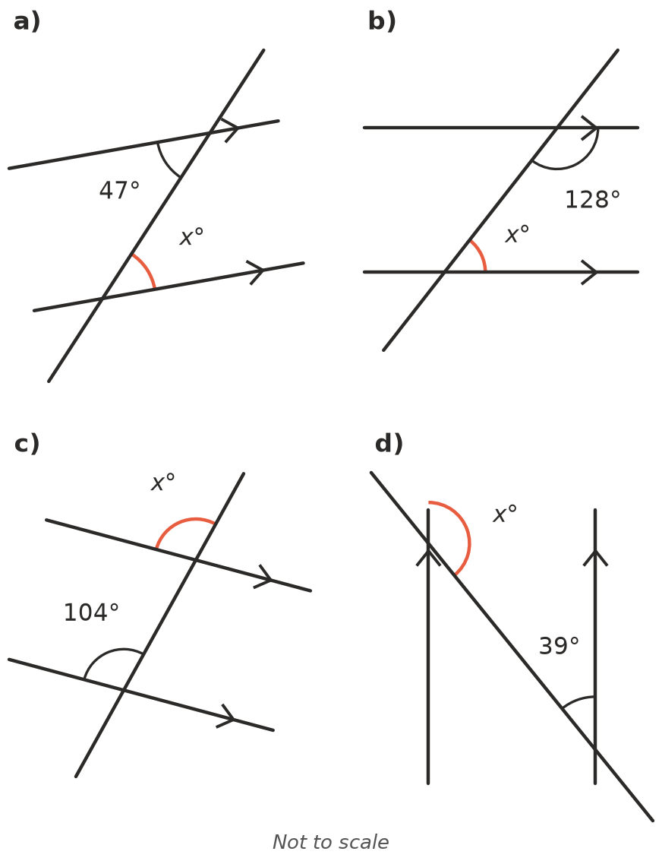
  - $x$ = ______________ Reason:
  - $x$ = ______________ Reason:
  - $x$ = ______________ Reason:
  - $x$ = ______________ Reason:
- Find the values of $x$ and $y$. Give a reason for each.
- 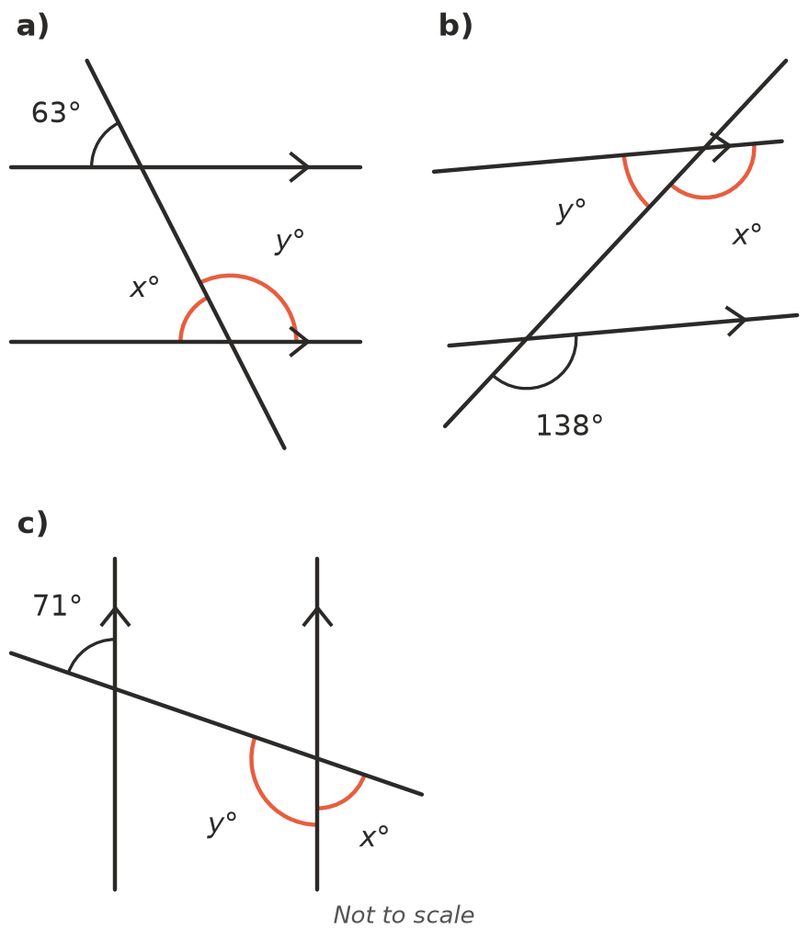
  - $x$ = ______________ $y$ = ______________ Reasons:
  - $x$ = ______________ $y$ = ______________ Reasons:
  - $x$ = ______________ $y$ = ______________ Reasons:
- In the diagram in Question 1, angle $e$ = 112°. Find the size of every other angle.
$a$ | $b$ | $c$ | $d$ | $f$ | $g$ | $h$

 Reasoning
- Decide whether each pair of lines is parallel. Explain how you know.
  - 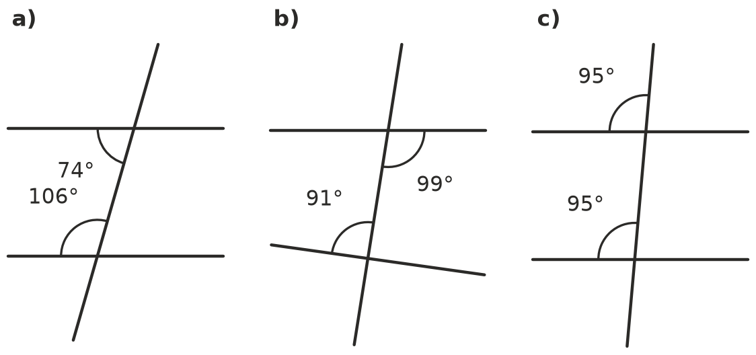

- Explain why co-interior angles on parallel lines add to 180°. Use corresponding angles and angles on a straight line in your answer. A sketch may help.
- Jess says, “$x$ = 50 because alternate angles are equal.” Explain why Jess is wrong.
- 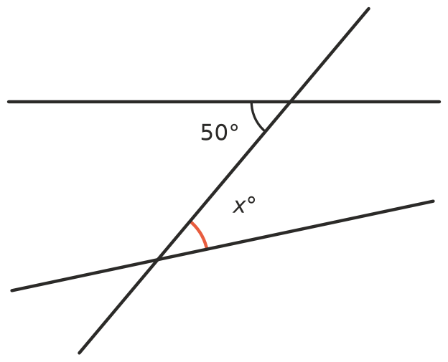

 Problem solving
- King St and Queen St are parallel. A straight road crosses them. Find $x$. Explain each step.
- 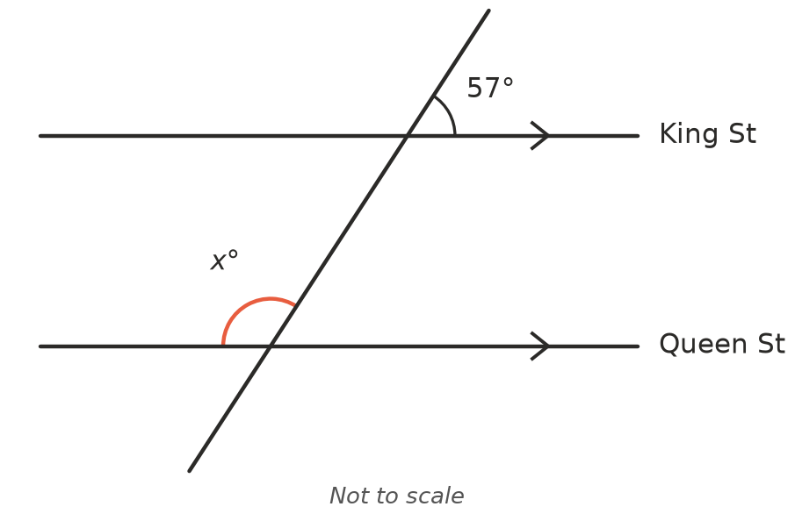
- $x$ =
- Three parallel lines are crossed by one transversal. Find $x$ and $y$.
- 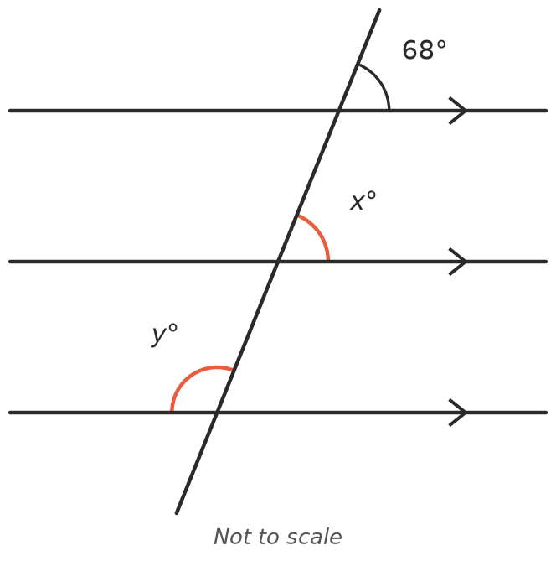
- Two pairs of parallel lines make a parallelogram. Find $a$, $b$ and $c$.
- 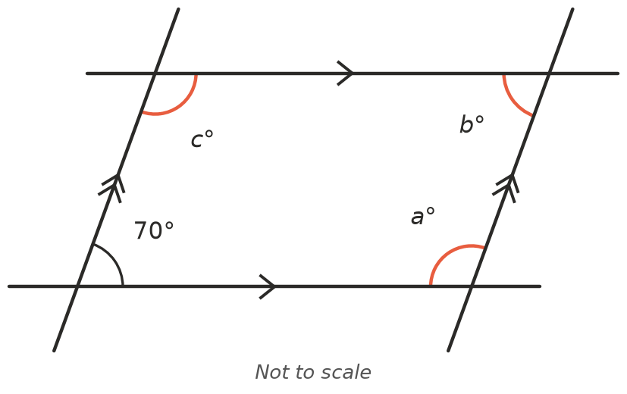
- Draw two parallel lines and a transversal so that one of the angles is 65°. Mark the parallel lines with arrows. Write the size of all eight angles on your diagram.

