11.01 Measure angles
Year 7 Maths · Worksheet · Level 3 · Challenge
Name: ____________________ Date: ______________
This worksheet practises measuring and drawing angles, including reflex angles, and using angle facts to reason about unknown angles. Tip: a full turn is 360°, a straight angle is 180° and a right angle is 90°. Most angle problems come back to one of these three numbers.

 Understanding
- Complete the table.
Fraction of a full turn | Size in degrees | Type of angle
$\frac{1}{4}$
$\frac{1}{3}$
$\frac{3}{4}$
$\frac{1}{8}$
$\frac{5}{12}$
$\frac{1}{2}$

- Six points are joined to the point O. ∠EOC is a right angle. The diagram is drawn at true size.
- 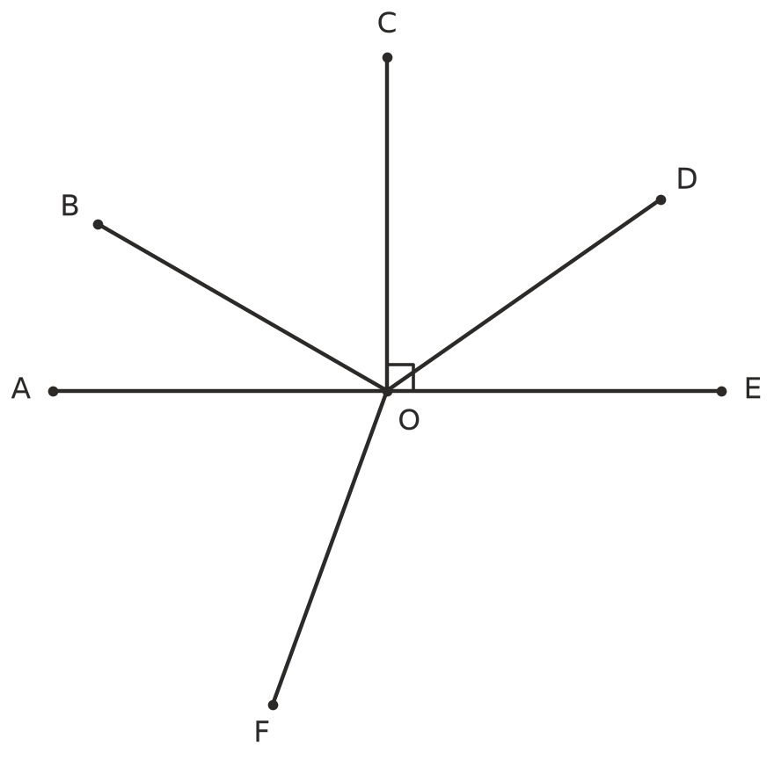
  - Measure ∠EOD and ∠COB. ______________
  - Without measuring, find ∠DOC. ______________
  - Without measuring, find ∠DOB. ______________
  - Measure ∠AOF. ______________
  - Without measuring, find the reflex angle ∠EOF. Explain how you found it. ______________
  - Name a pair of complementary angles in the diagram. ______________

 Fluency
- Use a protractor to measure each angle. The angles are drawn at true size. In parts d) and e), measure the reflex angle marked in red.
- 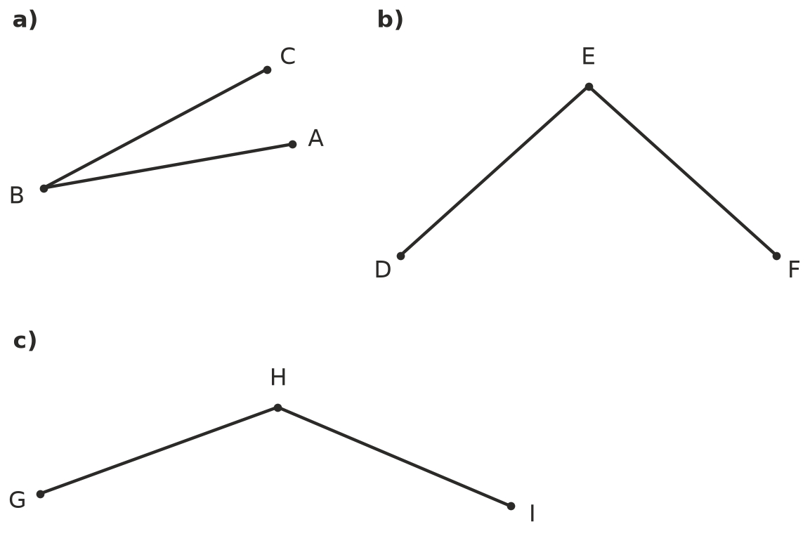
  - ∠ABC = ______________ b) ∠DEF = ______________ c) ∠GHI = ______________
- 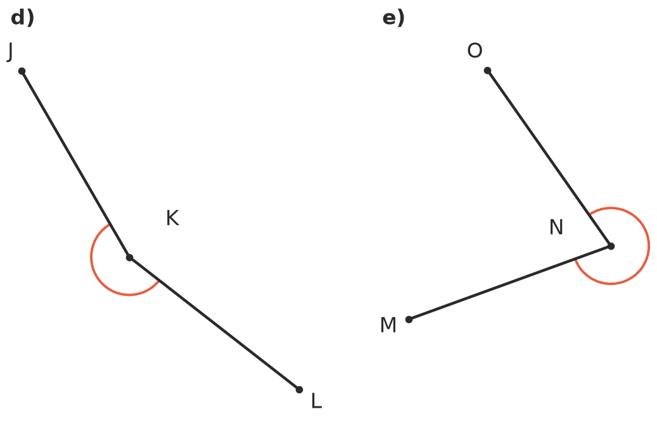
  - Reflex ∠JKL = ______________ e) Reflex ∠MNO = ______________
- Each angle has been started for you. Use a ruler and protractor to draw the second arm and label it.
- 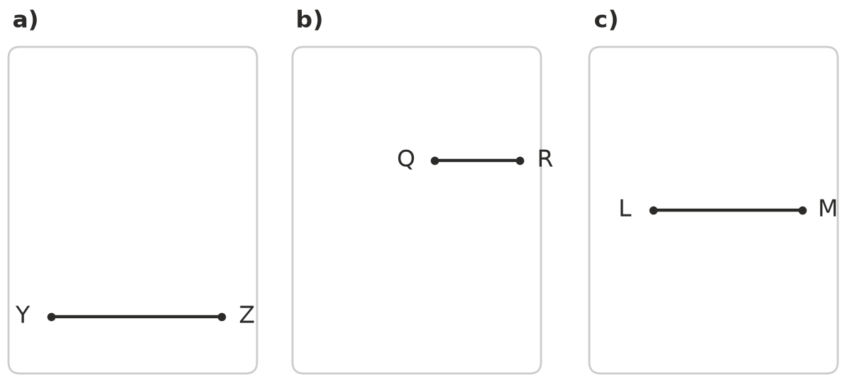
  - ∠XYZ = 72°
  - Reflex ∠PQR = 205° (draw the new arm below QR)
  - Reflex ∠KLM = 340° (draw the new arm below LM)
- Find the value of each pronumeral. Give a reason for each answer.
- 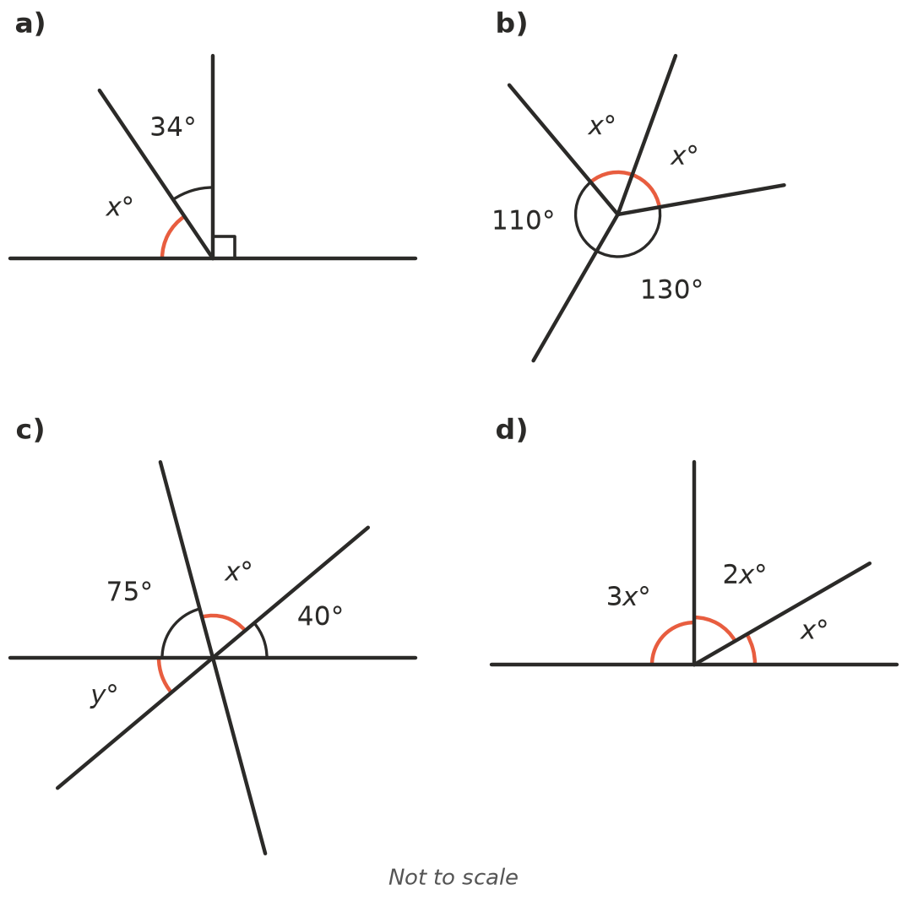
  - $x$ = ______________ Reason: ______________
  - $x$ = ______________ Reason: ______________
  - $x$ = ______________ $y$ = ______________ Reasons: ______________
  - $x$ = ______________ Reason: ______________

 Reasoning
- Show that the supplement of an angle is always 90° more than its complement. Use an example first, then explain why it works for any acute angle.

- Two straight lines cross. Use the fact that angles on a straight line add to 180° to explain why vertically opposite angles are always equal. A labelled sketch may help.

- On a clock, the minute hand turns 360° every hour. The hour hand turns 30° every hour, so it moves 0.5° every minute. Find the smaller angle between the hands at each time.
  - 3:30 ______________
  - 7:20 ______________
  - 10:10 ______________
- Ben wanted to measure a reflex angle. He measured the smaller angle as 64°, then added 180° and wrote 244°. Explain his mistake and find the correct size of the reflex angle.

 Problem solving
- The supplement of an angle is three times as big as its complement. Find the angle. Show your working or explain your thinking.

- Two angles are complementary. One angle is 24° bigger than the other. Find both angles.

- Five angles meet at a point. Each angle is 12° bigger than the one before it. Find the size of all five angles.

- AOB is a straight line. ∠AOC is three times as big as ∠COD. Find ∠COD and ∠AOC.
- 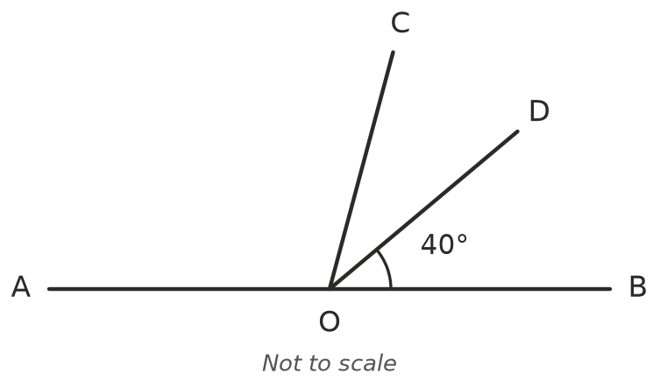

- ∠COD = ______________ ∠AOC = ______________

