11.01 Measure angles
Year 7 Maths · A5 question sheet · Level 2 · Core
This worksheet practises naming, measuring and drawing angles, and using angle facts to find unknown angles. Tip: before you measure, decide whether the angle is acute or obtuse. Then you will know which scale on the protractor to read. If an arm is too short to reach the scale, make it longer with a ruler.

 Understanding
- Write the type of angle for each size: acute, right, obtuse, straight, reflex or revolution.
  - 15°
  - 179°
  - 181°
  - 300°
  - 360°
  - 95°
- Four points are joined to the point O. The diagram is drawn at true size.
- 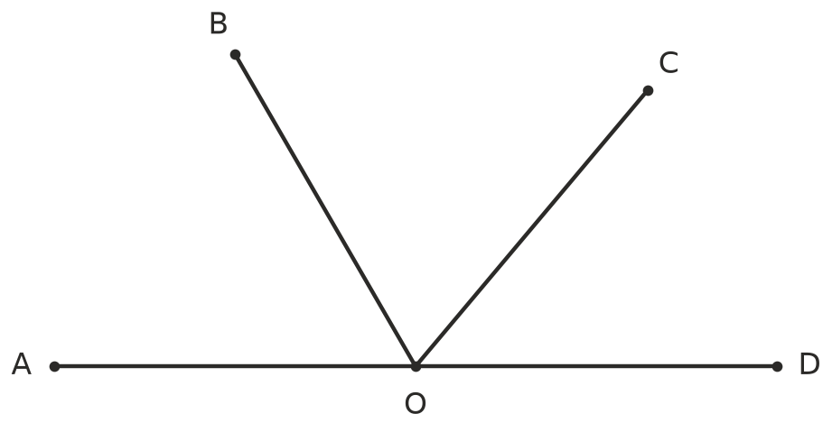
  - Which point is the vertex of every angle in the diagram?
  - Name two acute angles.
  - Name an obtuse angle.
  - Name the straight angle.
  - Measure ∠DOC and ∠COB.
  - Use your answers to part e) to work out ∠DOB without measuring it.

 Fluency
- Use a protractor to measure each angle. The angles are drawn at true size.
- 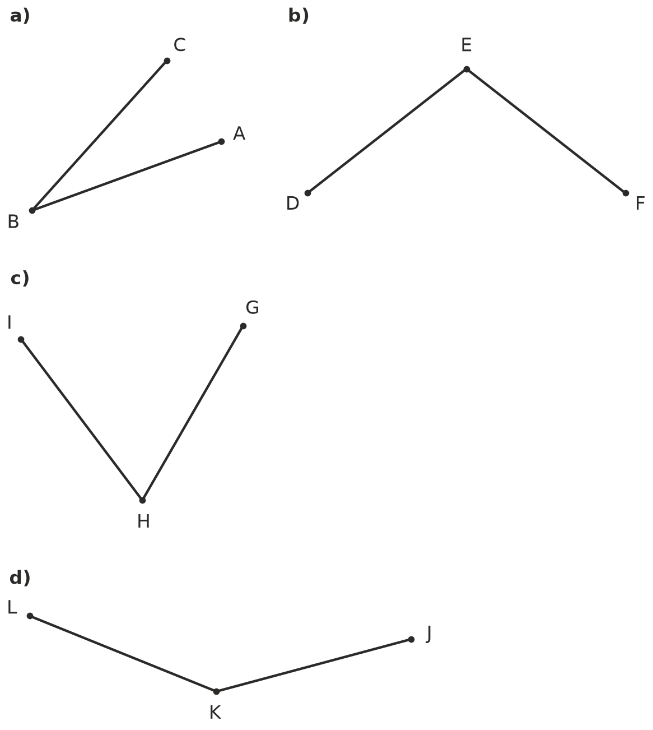
  - ∠ABC = ______________ b) ∠DEF = ______________ c) ∠GHI = ______________ d) ∠JKL =
- Measure each reflex angle marked in red. Tip: measure the smaller angle, then subtract it from 360°.
- 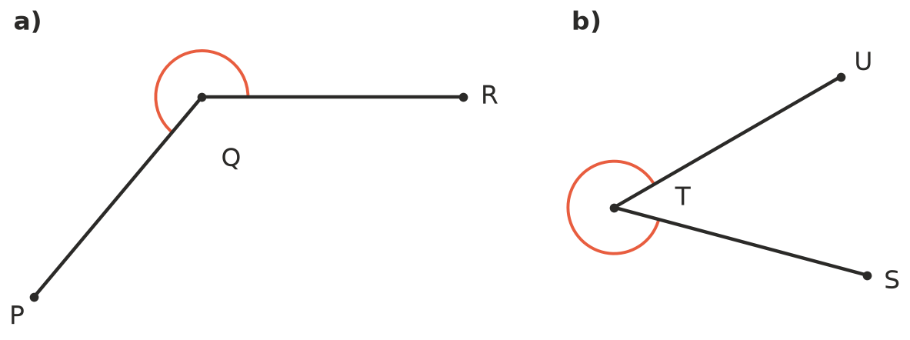
  - Reflex ∠PQR =
  - Reflex ∠STU =
- Each angle has been started for you. Use a ruler and protractor to draw the second arm and label it.
- 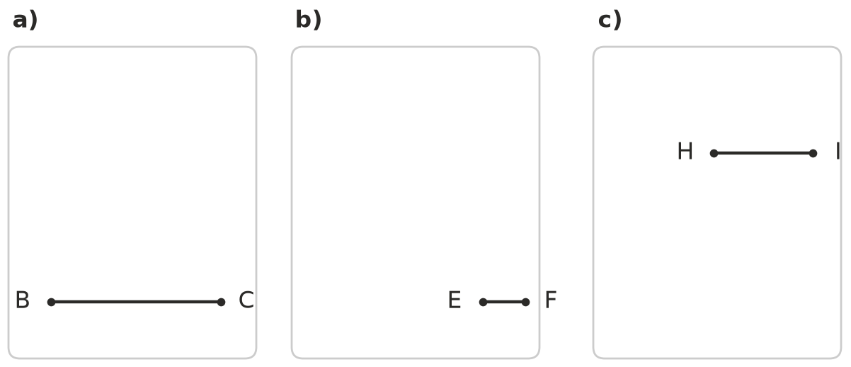
  - ∠ABC = 48°
  - ∠DEF = 160°
  - Reflex ∠GHI = 250° (draw the new arm below HI)
- Find the value of each pronumeral. Give a reason for each answer.
- 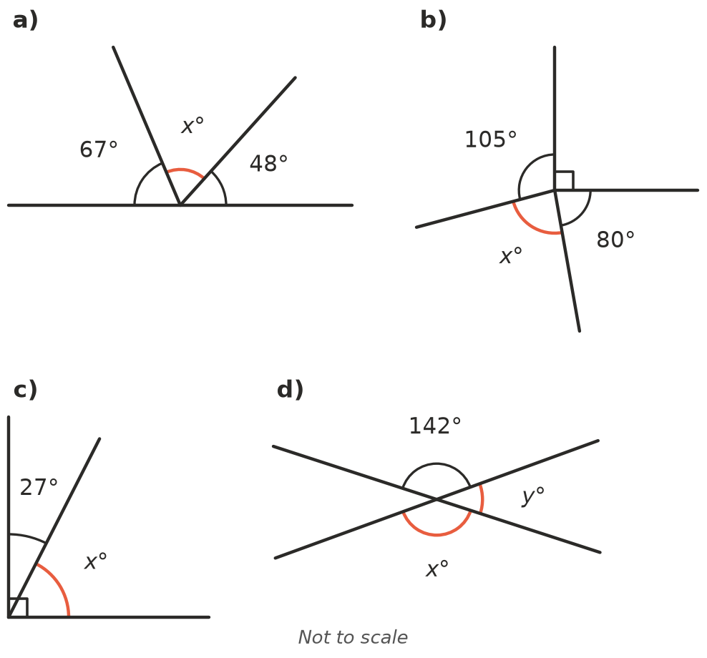
  - $x$ = ______________ Reason:
  - $x$ = ______________ Reason:
  - $x$ = ______________ Reason:
  - $x$ = ______________ $y$ = ______________ Reason:
- Complementary angles add to 90°. Supplementary angles add to 180°. Find:
  - the complement of 38°
  - the supplement of 38°
  - the supplement of 115°
  - the complement of 67°

 Reasoning
- Is each statement true or false? Write True or False in your book.
Statement
Two acute angles can add to an obtuse angle.
A reflex angle can have a supplement.
The supplement of an obtuse angle is always acute.
Vertically opposite angles add to 180°.
Two complementary angles are both acute.

- Mia measured ∠PQR and wrote 122°. Without measuring, explain how you know she is wrong. Then measure the angle.
- 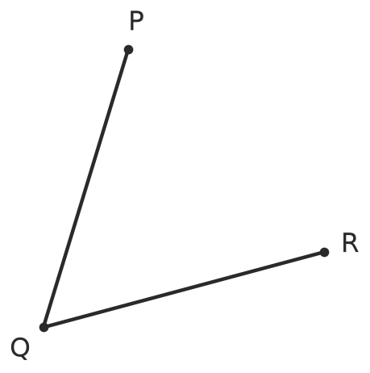
- ∠PQR =
- Use a clock face to answer these. Give the smaller angle between the hands unless the question asks for the reflex angle.
  - How many degrees apart are the numbers on a clock face? Explain how you know.
  - What is the angle between the hands at 5:00?
  - What is the angle between the hands at 10:00?
  - What is the reflex angle between the hands at 4:00?

 Problem solving
- A boom gate at a car park starts flat (horizontal). It swings up and stops at 72° above the horizontal.
  - How many more degrees must it turn to point straight up?
  - What angle does the raised boom make with the horizontal on the other side of its pivot?
- Find the angle between neighbouring spokes or blades. Each is evenly spaced around a centre.
  - A ceiling fan with 5 blades
  - A bike wheel with 12 spokes
  - A Ferris wheel with 18 spokes
- Find the value of $x$.
- 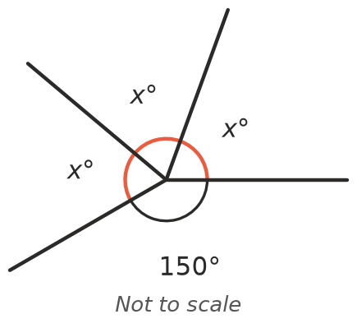
- $x$ =
- Three angles sit together on a straight line. The two smaller angles are equal and the largest angle is 100°. How big is each of the smaller angles? Show your working.

