11.01 Measure angles
Year 7 Maths · A5 question sheet · Level 1 · Warm-up
This worksheet practises naming angles, sorting them into types and measuring them with a protractor. Tip: put the centre of the protractor on the vertex and line up the zero line with one arm. Then read the scale that starts at 0 on that arm. If an arm is too short to reach the scale, make it longer with a ruler.

 Understanding
- Write the size, or the range of sizes, for each type of angle.
Angle type
Acute
Right
Obtuse
Straight
Reflex
Revolution

- Write the type of angle for each size.
  - 47°
  - 90°
  - 163°
  - 212°
  - 180°
  - 89°
- Look at this angle.
- 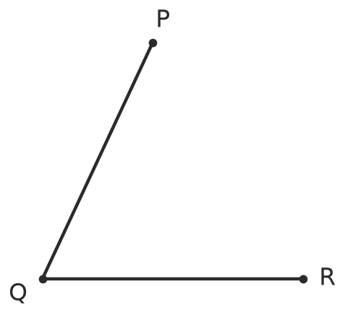
  - Which point is the vertex?
  - Name the angle using three letters.
  - Is the angle acute, obtuse or reflex?
- Write the type of each angle marked in red.
- 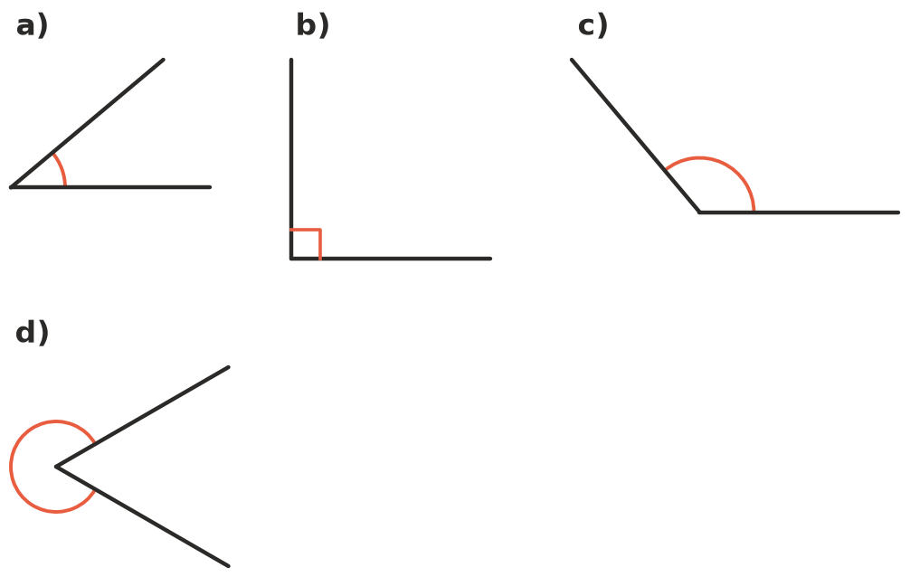
  - ______________ b) ______________ c) ______________ d)

 Fluency
- Use a protractor to measure each angle. The angles are drawn at true size.
- 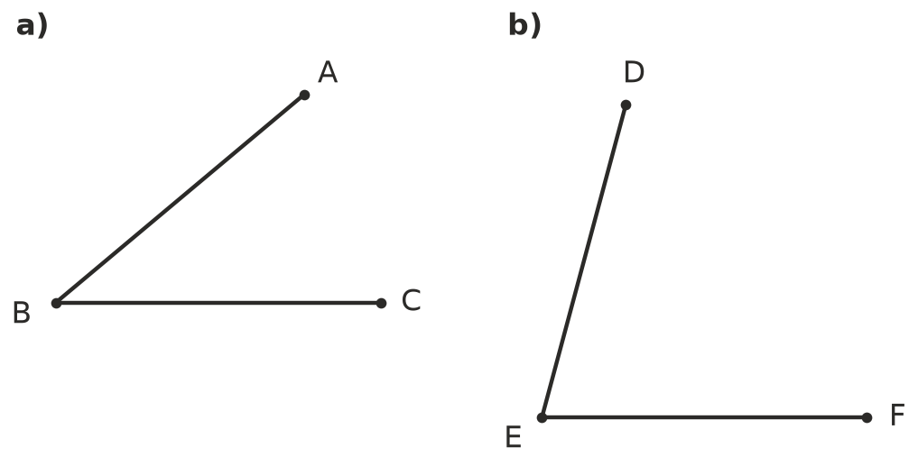
  - ∠ABC = ______________ b) ∠DEF =
- 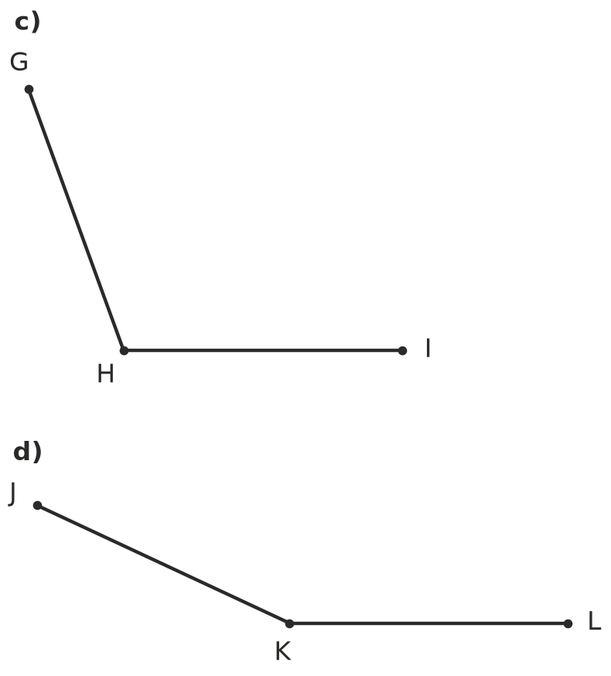
  - ∠GHI = ______________ d) ∠JKL =
- Each angle has been started for you. Use a ruler and protractor to draw the second arm. Label the end of your new arm.
- 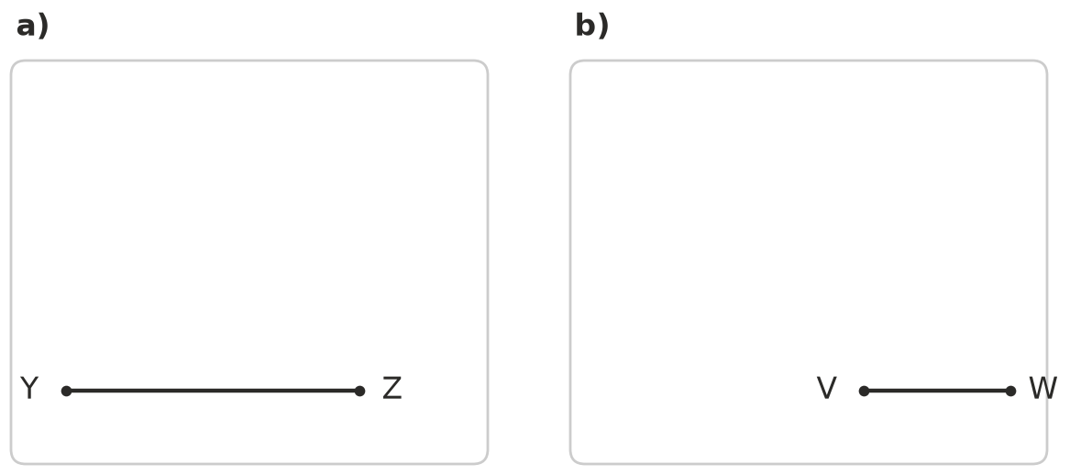
  - Draw ∠XYZ = 60°.
  - Draw ∠UVW = 135°.
- Find the value of $x$ in each diagram. Use these facts: angles on a straight line add to 180°, the parts of a right angle add to 90°, and angles around a point add to 360°.
- 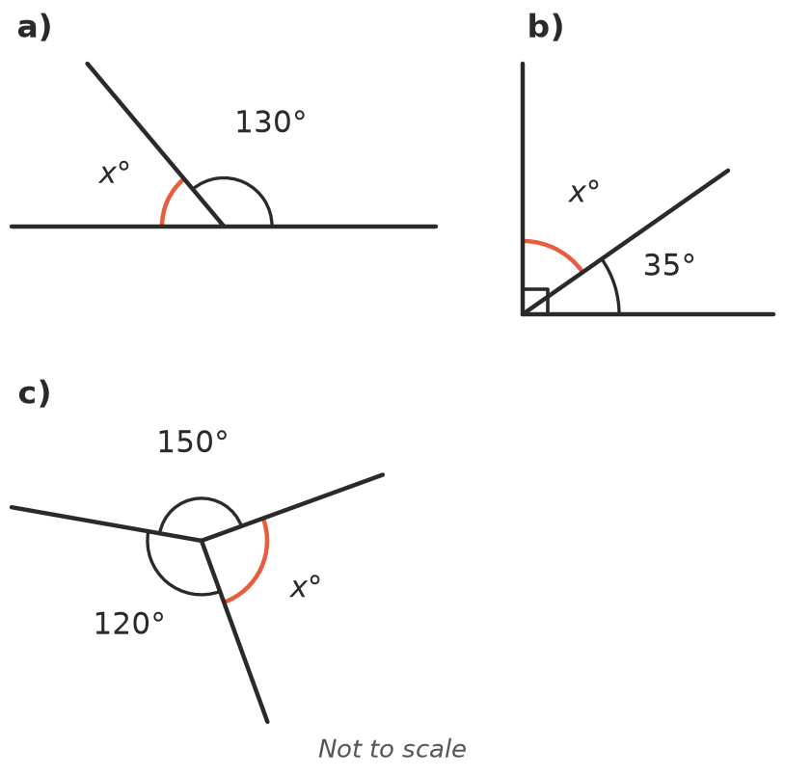
  - $x$ =
  - $x$ =
  - $x$ =

 Reasoning
- Two angles are complementary if they add to 90°. Two angles are supplementary if they add to 180°.
  - What angle is complementary to 30°?
  - What angle is supplementary to 70°?
  - Can two obtuse angles be supplementary? Explain.
- The numbers on a clock face are 30° apart. Copy and complete the table for the smaller angle between the hands.
Time | Angle between the hands
3:00
6:00
2:00
4:00

- Sam measured an acute angle and wrote down 140°. Explain what he probably did wrong. What is the true size of the angle?

 Problem solving
- Two straight lines cross. When two lines cross, the angles opposite each other are equal. These are called vertically opposite angles. Find the sizes of $a$, $b$ and $c$.
- 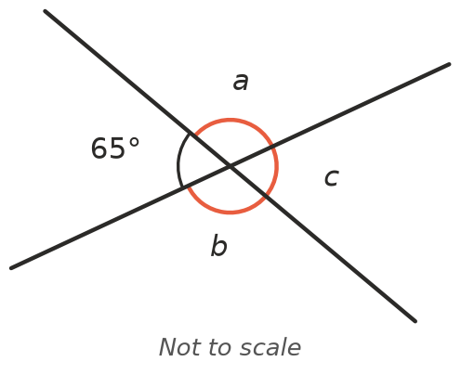
- A round pizza is cut into 8 equal slices from the centre.
  - What is the angle at the centre of each slice?
  - Jack eats 3 slices. What angle do his slices make at the centre? What type of angle is it?

