Algebra: Practice test 3
Year 7 Maths · Test · Test 3
Name: ____________________ Date: ______________
Time: 45 minutes
Total: 40 marks
Show your working in the boxes. Then write each final answer on the answer sheet on the last page. Write every expression in its simplest form, without × or ÷ signs.

 Section A: No calculator
- Answer these questions about variables and terms.
  - What is the coefficient of $e$ in the expression $7d+e+4$? (1 mark)

  - Write an expression that has three terms, where the coefficient of $x$ is 5 and the constant term is 8. (1 mark)

- Write each of these in simplest form.
  - $2×g×5$ (1 mark)

  - $p×q×4$ (1 mark)

  - $12×h÷3$ (1 mark)

- Write an algebraic expression for each of these.
  - 3 more than four times $k$ (1 mark)

  - the product of $m$ and $n$ (1 mark)

  - a number $b$ subtracted from 10 (1 mark)

  - the difference between $x$ and 5, multiplied by 3 (1 mark)

- At the cinema an adult ticket costs $$a$ and a child ticket costs $$c$.
  - Write an expression for the cost of 2 adult tickets and 3 child tickets. (1 mark)

  - Write an expression for the change from $100 after buying one adult ticket. (1 mark)

- Find the value of each expression when $m=7$ and $n=4$.
  - $3m+n$ (1 mark)

  - $mn−10$ (1 mark)

  - $5(m−n)$ (1 mark)

- Here is a growing pattern of dots.
- 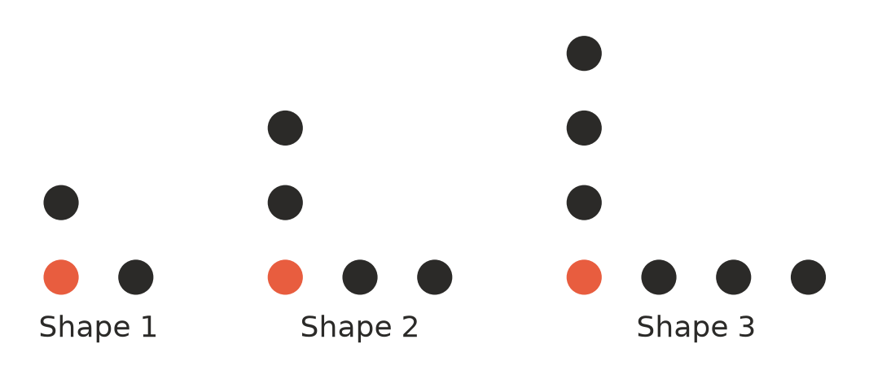
  - Complete the table. (1 mark)
Shape number ($n$) | 1 | 2 | 3 | 4 | 5
Number of dots ($d$) | 3 | 5 | 7

  - Write a rule for the number of dots, $d$, in Shape $n$. (1 mark)

  - Which shape has 41 dots? (1 mark)

- Write a rule for $y$ in terms of $x$ for this table of values. (1 mark)
$x$ | 1 | 2 | 3 | 4
$y$ | 3 | 7 | 11 | 15

- Simplify each expression by collecting like terms.
  - $10t−4t$ (1 mark)

  - $2a+5+3a+1$ (1 mark)

  - $4m+3n−m−3n$ (1 mark)

  - $5x^{2}+3x−2x^{2}+x$ (1 mark)

- The side lengths of this kite are shown in centimetres.
- 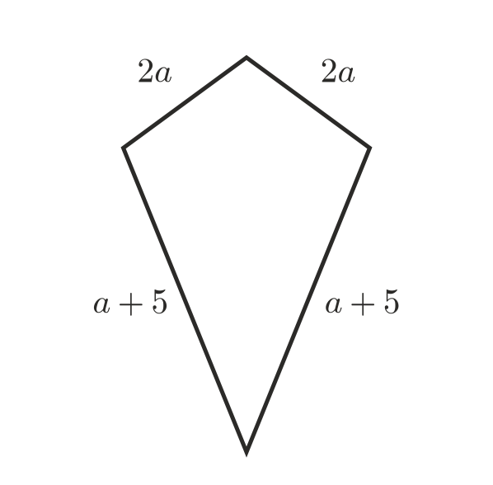
  - Write a simplified expression for the perimeter of the kite. (2 marks)

  - Find the perimeter when $a=3$. (1 mark)

- Is $4+3n$ the same as $7n$? Explain your answer, using $n=2$ to help you. (2 marks)

- Here is a number trick: think of a number, add 3, multiply the result by 2, then subtract 6.
  - Let the starting number be $n$. Write an expression for the answer to the trick. Use brackets where you need them. (1 mark)

  - Try the trick with a few different starting numbers. Describe how the answer is always connected to the starting number. (1 mark)

 Section B: Calculator allowed
- A taxi fare, $F$ dollars, for a trip of $d$ kilometres is given by $F=4.20+2.35d$.
  - Find the fare for a 12 km trip. (1 mark)

  - A fare was $51.20. How long was the trip? (1 mark)

  - A second company charges $F=7+2.15d$. Which company is cheaper for a 30 km trip? Show your working. (1 mark)

- Find the value of each expression when $x=1.6$ and $y=25$.
  - $8x+y$ (1 mark)

  - $y−x^{2}$ (1 mark)

- The distance travelled, $D$ km, is given by $D=st$, where $s$ is the speed in km/h and $t$ is the time in hours. How far does a car travel at 92 km/h for 3.5 hours? (1 mark)

- For a church fundraiser, Ava sells $t$ raffle tickets. Jack sells 3 more than twice as many tickets as Ava.
  - Write an expression for the number of tickets Jack sells. (1 mark)

  - Write a simplified expression for the total number of tickets Ava and Jack sell. (1 mark)

  - Each ticket costs $2.50. Ava sells 46 tickets. How much money do Ava and Jack raise altogether? (1 mark)

- In a theatre, row $r$ has $2r+14$ seats.
  - How many seats are in row 25? (1 mark)

  - Which row has 90 seats? (1 mark)

 Answer sheet
Name: ____________________
Write your final answer for each question in the table.
Question | Answer | Marks | Question | Answer | Marks
1a |  | /1 | 8b |  | /1
1b |  | /1 | 8c |  | /1
2a |  | /1 | 8d |  | /1
2b |  | /1 | 9a |  | /2
2c |  | /1 | 9b |  | /1
3a |  | /1 | 10 |  | /2
3b |  | /1 | 11a |  | /1
3c |  | /1 | 11b |  | /1
3d |  | /1 | 12a |  | /1
4a |  | /1 | 12b |  | /1
4b |  | /1 | 12c |  | /1
5a |  | /1 | 13a |  | /1
5b |  | /1 | 13b |  | /1
5c |  | /1 | 14 |  | /1
6a |  | /1 | 15a |  | /1
6b |  | /1 | 15b |  | /1
6c |  | /1 | 15c |  | /1
7 |  | /1 | 16a |  | /1
8a |  | /1 | 16b |  | /1
 |  |  |  | Total | /40

