Algebra: Practice test 2
Year 7 Maths · Test · Test 2
Name: ____________________ Date: ______________
Time: 45 minutes
Total: 40 marks
Show your working in the boxes. Then write each final answer on the answer sheet on the last page. Write every expression in its simplest form, without × or ÷ signs.

 Section A: No calculator
- Look at the expression $4g+h+11$. Write true or false for each statement.
  - The expression has three terms. (1 mark)

  - The coefficient of $h$ is 0. (1 mark)

  - The variables in the expression are $g$, $h$ and 11. (1 mark)

- Write each of these in simplest form.
  - $y×9$ (1 mark)

  - $3×m×n×2$ (1 mark)

  - $d÷5$ (1 mark)

- Write an algebraic expression for each of these.
  - 6 less than $w$ (1 mark)

  - 9 more than twice $z$ (1 mark)

  - the sum of $a$ and $b$, divided by 2 (1 mark)

- A carton holds 12 eggs.
  - Write an expression for the number of eggs in $c$ full cartons. (1 mark)

  - Ben has $c$ full cartons and 5 loose eggs. Write an expression for the total number of eggs Ben has. (1 mark)

- Find the value of each expression when $x=6$, $y=2$ and $z=5$.
  - $4x−y$ (1 mark)

  - $xy+z$ (1 mark)

  - $2(z−y)$ (1 mark)

  - $\frac{x}{y}+3z$ (1 mark)

- This growing pattern of houses is made from matchsticks.
- 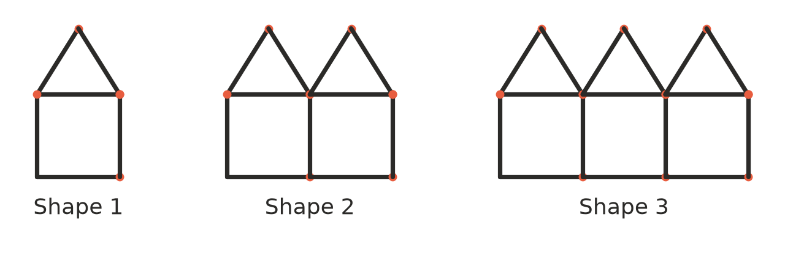
  - Complete the table. (1 mark)
Shape number ($n$) | 1 | 2 | 3 | 4 | 5
Number of matchsticks ($m$) | 6 | 11 | 16

  - Write a rule for the number of matchsticks, $m$, in Shape $n$. (1 mark)

  - How many matchsticks are needed for Shape 10? (1 mark)

- Simplify each expression by collecting like terms.
  - $5c+c$ (1 mark)

  - $8k−3k−5k$ (1 mark)

  - $6p+2q−4p+3q$ (1 mark)

  - $7+3a−2+4a+b$ (1 mark)

- The side lengths of this triangle are shown in centimetres.
- 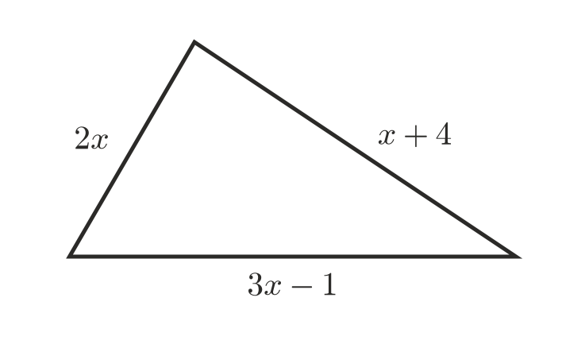
  - Write a simplified expression for the perimeter of the triangle. (2 marks)

  - Find the perimeter when $x=4$. (1 mark)

- Noah is asked to find the value of $5n$ when $n=3$. He writes 53. Explain Noah’s mistake, then give the correct value. (2 marks)

- Priya says, “$2x$ is always bigger than $x+2$.” Is Priya correct? Use substitution to explain your answer. (2 marks)

 Section B: Calculator allowed
- A plumber charges a call-out fee of $85 plus $68 for each hour of work.
  - Write a formula for the cost, $C$ dollars, of a job that takes $h$ hours. (1 mark)

  - Find the cost of a job that takes 3.5 hours. (1 mark)

  - A job cost $425. How many hours did it take? (1 mark)

- Find the value of each expression when $a=3.2$ and $b=7.5$.
  - $5a+2b$ (1 mark)

  - $a^{2}+b$ (1 mark)

- The formula $F=1.8C+32$ changes a temperature in degrees Celsius ($C$) to degrees Fahrenheit ($F$).
  - Change 35 °C to degrees Fahrenheit. (1 mark)

  - Water boils at 212 °F. What is this temperature in degrees Celsius? (1 mark)

- A florist makes $s$ small bunches with 5 flowers in each and $l$ large bunches with 12 flowers in each.
  - Write an expression for the total number of flowers used. (1 mark)

  - The florist makes 38 small bunches and 17 large bunches. How many flowers is that? (1 mark)

- A polygon with $n$ sides has $D$ diagonals, where $D=\frac{n(n−3)}{2}$.
  - How many diagonals does a polygon with 24 sides have? (1 mark)

  - A polygon has 170 diagonals. How many sides does it have? Show how you found it. (1 mark)

 Answer sheet
Name: ____________________
Write your final answer for each question in the table.
Question | Answer | Marks | Question | Answer | Marks
1a |  | /1 | 7b |  | /1
1b |  | /1 | 7c |  | /1
1c |  | /1 | 7d |  | /1
2a |  | /1 | 8a |  | /2
2b |  | /1 | 8b |  | /1
2c |  | /1 | 9 |  | /2
3a |  | /1 | 10 |  | /2
3b |  | /1 | 11a |  | /1
3c |  | /1 | 11b |  | /1
4a |  | /1 | 11c |  | /1
4b |  | /1 | 12a |  | /1
5a |  | /1 | 12b |  | /1
5b |  | /1 | 13a |  | /1
5c |  | /1 | 13b |  | /1
5d |  | /1 | 14a |  | /1
6a |  | /1 | 14b |  | /1
6b |  | /1 | 15a |  | /1
6c |  | /1 | 15b |  | /1
7a |  | /1
 |  |  |  | Total | /40

