8.04 Collect like terms
Year 7 Maths · Worksheet · Level 3 · Challenge
Name: ____________________ Date: ______________
This worksheet practises simplifying longer expressions with several kinds of like terms. Tip: like terms must have the same variables with the same powers. Work through the expression one kind of term at a time, and keep the sign in front of each term with it.

 Understanding
- Explain why $5xy$ and $3yx$ are like terms, but $5x^{2}y$ and $3xy^{2}$ are not.

- Write true or false for each statement.
  - $2x^{2}+3x^{2}=5x^{4}$ ______________
  - $6pq−pq=5pq$ ______________
  - $x+x^{2}+x^{3}$ cannot be simplified. ______________
  - $9mn−2nm+3=7mn+3$ ______________

 Fluency
- Simplify.
  - $8x+5y−3x+2y−y$ = ______________
  - $4a^{2}+3a−a^{2}+6a$ = ______________
  - $7pq+2p−3qp+5p$ = ______________
  - $12+5m−4+3n−2m$ = ______________
  - $4a+3b+2a^{2}+ab+5b+7ba+a$ = ______________
  - $\frac{3x}{4}+\frac{x}{4}$ = ______________
  - $6k^{2}+4k−2k^{2}−4k+1$ = ______________
- In each pyramid, each brick is the sum of the two bricks below it. Fill in the empty bricks, writing each one in its simplest form.
- 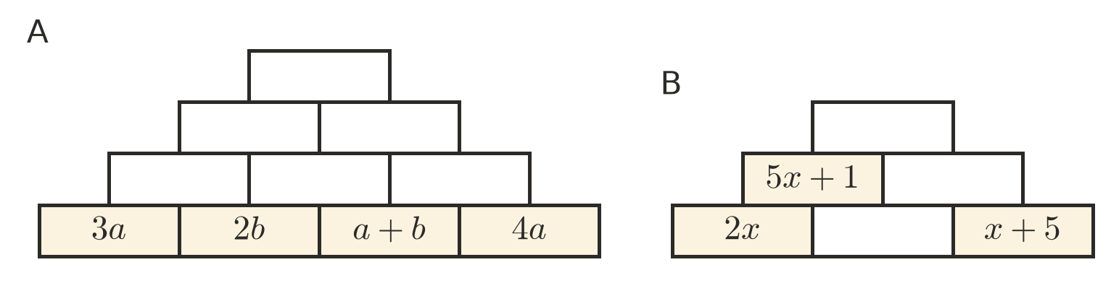
- Simplify. Do the multiplication first.
  - $2×3x+x$ = ______________
  - $4m×2−3m$ = ______________
  - $5a+a×4$ = ______________

 Reasoning
- Kim simplified $6x+3−2x+5$ and got $4x+2$. Find her mistake and give the correct answer. Check your answer by substituting $x=2$.

- Find the missing numbers: $▫a+4b+2a−▫b=9a+b$ ______________
- Simplify $3n+6+2n+4$. Is the result always a multiple of 5 when $n$ is a whole number? Explain.

 Problem solving
- Here is an L-shaped garden bed. The lengths are in metres.
- 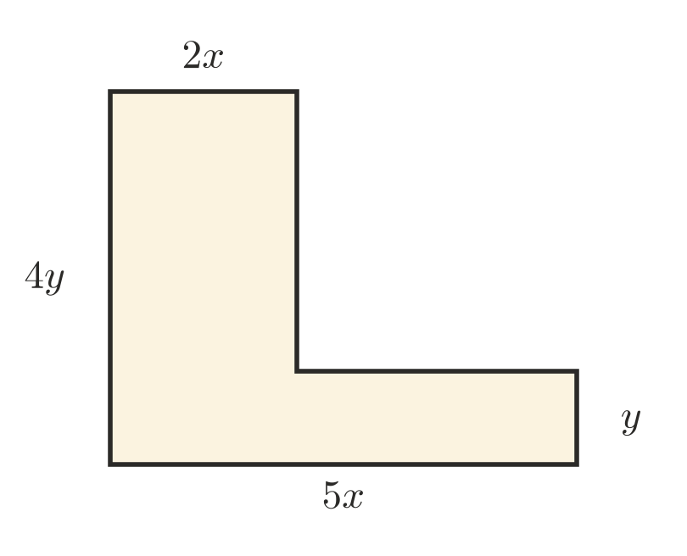
  - Write expressions for the lengths of the two unlabelled sides. ______________
  - Write a simplified expression for the perimeter. ______________
  - Find the perimeter when $x=2$ and $y=3$. ______________
- On Friday, Year 7 sells $c$ cupcakes at $3 each and $b$ brownies at $4 each. On Saturday they sell twice as many cupcakes as on Friday, at the same price, and 10 brownies.
  - Write a simplified expression for the total money they take in over the two days. ______________
  - Find the total when $c=20$ and $b=15$. ______________
- The perimeter of a triangle is $12a+5$. Two of its sides are $4a+1$ and $3a$. Find an expression for the third side. ______________
- In a magic square, every row, column and diagonal has the same total.
$x+1$ | $x+6$ | $x+5$
 | $x+4$

  - Find the magic total by adding the top row. Simplify your answer. ______________
  - Fill in the empty squares.

