8.04 Collect like terms
Year 7 Maths · A5 question sheet · Level 2 · Core
This worksheet practises simplifying expressions by collecting like terms. Tip: like terms have exactly the same variables with the same powers. $3xy$ and $5yx$ are like terms, but $4m$ and $4m^{2}$ are not. Group the like terms first, then add or subtract their coefficients.

 Understanding
- Sort these terms into groups of like terms.
- $5x$, $3y$, $x^{2}$, $2x$, 7, $4y$, $xy$, $3x^{2}$, $yx$, 1
- Write true or false for each statement.
  - $3ab$ and $5ba$ are like terms.
  - $4m$ and $4m^{2}$ are like terms.
  - $7x−7x=0$
  - $2a+3b=5ab$

 Fluency
- Simplify.
  - $7a+4a−2a$ =
  - $12k−5k+k$ =
  - $3xy+6xy$ =
  - $8mn−3nm$ =
  - $4p^{2}+5p^{2}$ =
  - $11t−4t−7t$ =
- Simplify by collecting like terms.
  - $5x+3y+2x+y$ =
  - $6a+4+3a−1$ =
  - $9m+2n−4m+5n$ =
  - $8+3c+2+5c$ =
  - $4x^{2}+3x+2x^{2}+x$ =
  - $7ab+3a+2ba−a$ =
  - $10p+6q−3p−6q$ =
- In this pyramid, each brick is the sum of the two bricks below it. Copy and fill in the empty bricks, writing each one in its simplest form.
- 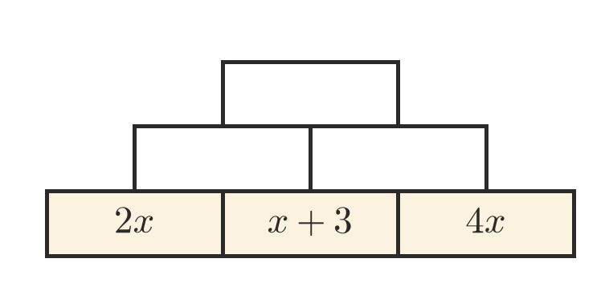

 Reasoning
- Lucas says that $3a+4a^{2}=7a^{3}$. Explain why he is wrong.
- Simplify $4n+2+3n$. Then substitute $n=5$ into both the original expression and your answer to check that they give the same value.
- Which expression is not equal to $6m+4$?
  - $2m+4+4m$
  - $10m$
  - $m+3+5m+1$
  - $8m+4−2m$

 Problem solving
- Here are a triangle and a rectangle. The lengths are in centimetres.
- 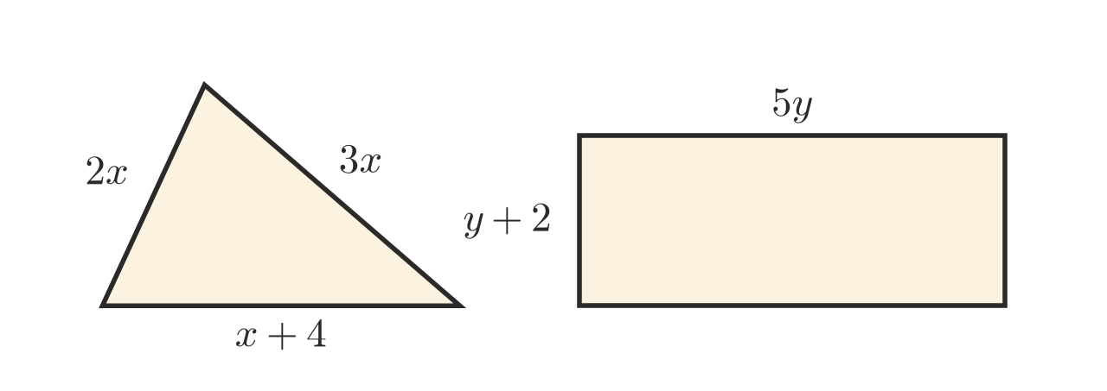
  - Write a simplified expression for the perimeter of the triangle.
  - Write a simplified expression for the perimeter of the rectangle.
  - Find the perimeter of the triangle when $x=3$.
- At the canteen, pies cost $p$ dollars and drinks cost $d$ dollars. Ella buys 3 pies and 2 drinks. Sam buys 1 pie and 4 drinks.
  - Write a simplified expression for the total they spend.
  - Find the total when pies cost $5 and drinks cost $3.
- Write an expression with four terms that simplifies to $5a+2b$.
- Three friends collect cans for a fundraiser. Jo collects $n$ cans. Kai collects 3 times as many as Jo. Lena collects 10 more than Kai.
  - Write expressions for the number of cans Kai and Lena collect.
  - Write a simplified expression for the total number of cans.
  - Jo collects 15 cans. How many cans do they collect altogether?

