8.04 Collect like terms
Year 7 Maths · A5 question sheet · Level 1 · Warm-up
This worksheet practises simplifying expressions by collecting like terms. Tip: like terms have exactly the same letters. Add or subtract their coefficients and keep the letters the same, so $3a+5a=8a$. Terms that are not like terms, such as $3a$ and $2b$, stay separate.

 Understanding
- Are these like terms? Write yes or no.
  - $4x$ and $9x$
  - $3a$ and $3b$
  - $5m$ and $m$
  - $2y$ and 7
  - $6pq$ and $2qp$
  - $k$ and $k^{2}$
- Write down the two like terms in each list.
  - $3n$, $5p$, $n$, 4
  - $2ab$, $7a$, $ba$, $b$

 Fluency
- Simplify.
  - $2a+3a$ =
  - $6x+x$ =
  - $9m−4m$ =
  - $5k−k$ =
  - $3y+2y+4y$ =
  - $10t−3t−2t$ =
  - $4ab+5ab$ =
  - $8p−8p$ =
- Simplify by collecting the like terms.
  - $3a+2b+4a$ =
  - $5x+3+2x$ =
  - $m+6n+2m+n$ =
  - $7c+5−2c+1$ =
  - $4y+9−3$ =
- In this pyramid, each brick is the sum of the two bricks below it. Copy and fill in the empty bricks.
- 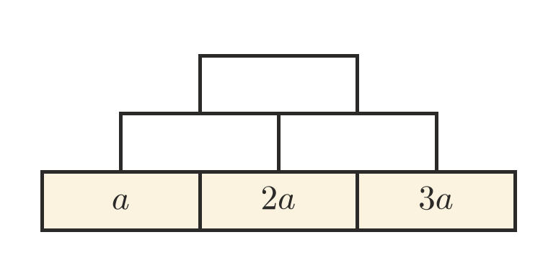

 Reasoning
- Sam simplified $4x+3y$ to $7xy$. Explain his mistake.
- Which expression is equal to $5n+2n+3$?
  - $10n$
  - $7n+3$
  - $7n^{2}+3$
  - $5n+5$

 Problem solving
- Here is a rectangle.
- 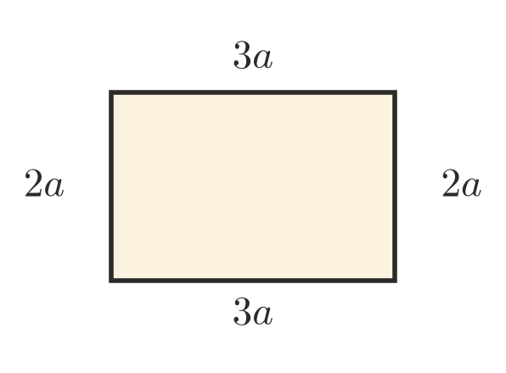
  - Write the perimeter as a sum of the four sides.
  - Simplify your answer to part a.
  - Find the perimeter when $a=4$ cm.
- Bags of oranges each hold $n$ oranges. Ruby buys 3 bags and Tom buys 4 bags. On the road trip they eat 2 bags of oranges. Write a simplified expression for the number of oranges they have left.
- Year 7 sells pies for $p$ dollars each at a fundraiser. They sell 12 pies on Monday and 9 pies on Tuesday.
  - Write a simplified expression for the money they take in.
  - Find the money they take in when pies cost $5.
- Write an expression with three terms that simplifies to $6x$.

