8.03 Substitution
Year 7 Maths · Worksheet · Level 3 · Challenge
Name: ____________________ Date: ______________
This worksheet practises substituting into harder expressions and formulas, and working backwards from a formula. Tip: a power only applies to what it is attached to, so $3n^{2}$ means 3 × $n$ × $n$, but $(3n)^{2}$ means $3n$ × $3n$.

 Understanding
- Find the value of $3n^{2}$ and of $(3n)^{2}$ when $n=2$. Explain why they are different.

 Fluency
- Find the value of each expression when $p=6$, $q=2$ and $r=5$.
  - $pqr$ = ______________
  - $\frac{p}{q}+r$ = ______________
  - $p^{2}−q^{2}$ = ______________
  - $3(p+r)−q$ = ______________
  - $\frac{p+r+1}{q}$ = ______________
  - $4pq−r^{2}$ = ______________
  - $(p−q)^{2}+r$ = ______________
  - $\frac{5p}{3q}$ = ______________
- Complete the table of values.
$x$ | 1 | 2 | 3 | 4 | 6
$2x^{2}+1$
$\frac{12}{x}+x$
$x(10−x)$

- Use each formula to find the value asked for.
  - The area of a trapezium is $A=\frac{(a+b)h}{2}$. Find $A$ when $a=6$ cm, $b=10$ cm and $h=5$ cm. ______________
  - To change degrees Celsius to degrees Fahrenheit, use $F=\frac{9C}{5}+32$. Find $F$ when $C=25$. ______________
  - The volume of a box is $V=lwh$. Find $V$ when $l=8$ cm, $w=5$ cm and $h=3$ cm. ______________
  - Distance travelled is $d=vt$. Find $d$ when $v=95$ km per hour and $t=4$ hours. ______________

 Reasoning
- Here is Kim’s working: “When $a=3$ and $b=4$, $ab^{2}={12}^{2}=144$.” Explain her mistake and find the correct value.

- For which whole numbers $x$ from 1 to 8 is $4x+9$ greater than $x^{2}$? Show your working.

- Find two whole numbers $a$ and $b$ so that $a+b=10$ and $ab=21$. ______________

 Problem solving
- Here is a growing pattern of hexagons made from matchsticks.
- 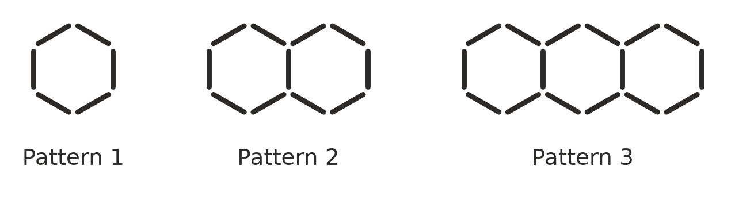
Number of hexagons, $h$ | 1 | 2 | 3 | 4 | 5
Number of matchsticks, $M$ | 6

  - Complete the table.
  - The rule is $M=5h+1$. Explain where the 5 and the 1 in the rule come from, using the pictures.

  - How many matchsticks are needed for 12 hexagons? ______________
  - How many hexagons are in the pattern that uses 101 matchsticks? ______________
- Plumber A charges $C=90h+65$ dollars for a job that takes $h$ hours. Plumber B charges $C=75h+110$ dollars.
  - Find what Plumber A charges for a 3-hour job. ______________
  - Show that both plumbers charge the same for a 3-hour job. ______________
  - Which plumber is cheaper for a 5-hour job, and by how much? ______________
  - Plumber A’s bill was $515. How many hours did the job take? ______________
- In Aussie Rules footy, a team’s score is $S=6g+b$, where $g$ is goals and $b$ is behinds.
  - A team kicked 10 goals and scored 71 points. How many behinds did they kick? ______________
  - A team scored 50 points and kicked more goals than behinds. Find the only way they could have done this. ______________
- A rectangle has perimeter $P=2(l+w)$ and area $A=lw$. The length $l$ and width $w$ are whole numbers of centimetres. Find the length and width when $P=26$ cm and $A=40$ cm². ______________
- A water tank holds 1200 litres. A pump adds 450 litres every minute. The amount of water in the tank after $t$ minutes is $L=1200+450t$.
  - How much water is in the tank after 20 minutes? ______________
  - The tank is full when it holds 12 000 litres. After how many minutes is it full? ______________

