8.03 Substitution
Year 7 Maths · A5 question sheet · Level 2 · Core
This worksheet practises substituting numbers into expressions and formulas. Tip: write the numbers in place of the letters with × signs back in, then follow the order of operations. For example, when $k=7$, $3k−1$ = 3 × 7 − 1 = 20.

 Understanding
- When $k=7$, find the value of each expression.
  - $5k$ =
  - $k^{2}$ =
  - $3k−1$ =
  - $\frac{k+3}{2}$ =

 Fluency
- Find the value of each expression when $x=4$.
  - $9x$ =
  - $x+15$ =
  - $30−x$ =
  - $5x−8$ =
  - $\frac{x}{2}+6$ =
  - $x^{2}+1$ =
  - $3(x+2)$ =
  - $\frac{24}{x}$ =
- Find the value of each expression when $a=3$, $b=5$ and $c=10$.
  - $a+b+c$ =
  - $abc$ =
  - $2a+3b$ =
  - $c−2a$ =
  - $bc−a$ =
  - $\frac{c}{b}+a$ =
  - $a^{2}+b$ =
  - $4(c−b)$ =
- Copy and complete the table of values.
$x$ | 0 | 1 | 2 | 3 | 4
$3x+2$
$20−4x$
$x^{2}$

- Use each formula to find the value asked for.
  - The perimeter of a rectangle is $P=2l+2w$. Find $P$ when $l=12$ cm and $w=7$ cm.
  - The area of a triangle is $A=\frac{bh}{2}$. Find $A$ when $b=10$ cm and $h=6$ cm.
  - Average speed is $s=\frac{d}{t}$. Find $s$ when $d=240$ km and $t=3$ hours.
  - A taxi fare in dollars is $C=4+2k$, where $k$ is the number of kilometres. Find $C$ when $k=15$.

 Reasoning
- Here is Ryan’s working: “When $m=6$, $4+2m$ = 6 × 6 = 36.” Explain his mistake and find the correct value.
- Find the whole number $n$ for which $2n+5$ and $3n$ have the same value. Try $n=1,2,3,…$ and show your working.

 Problem solving
- Here is a growing pattern of triangles made from matchsticks.
- 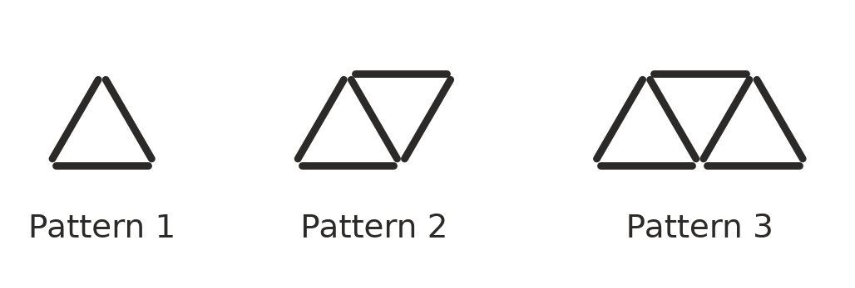
Number of triangles, $t$ | 1 | 2 | 3 | 4 | 5
Number of matchsticks, $M$ | 3 | 5 | 7

  - Copy and complete the table.
  - Show that the rule $M=2t+1$ works for the first three patterns.
  - How many matchsticks are needed for 20 triangles?
  - How many triangles can be made in this pattern with 61 matchsticks?
- In Aussie Rules footy, a team’s score is $S=6g+b$, where $g$ is the number of goals and $b$ is the number of behinds.
  - Find the score for 14 goals and 8 behinds.
  - The Swans kicked 11 goals and 15 behinds. The Lions kicked 12 goals and 6 behinds. Which team won, and by how many points?
- The cost in dollars of a church camp for $n$ nights is $C=45n+60$. (The $60 pays for the bus.)
  - Find the cost of a 3-night camp.
  - Find the cost of a 5-night camp.
  - Sarah has $250. What is the greatest number of nights she can afford?
- The area of a square is $A=s^{2}$, where $s$ is the side length.
  - Find the area of a square with sides of 9 m.
  - A square has an area of 144 m². What is its side length?
- When everyone in a group of $p$ people shakes hands once with everyone else, the number of handshakes is $H=\frac{p(p−1)}{2}$.
  - How many handshakes are there in a group of 5 people?
  - How many handshakes are there in a youth group of 12 people?

