8.03 Substitution
Year 7 Maths · A5 question sheet · Level 1 · Warm-up
This worksheet practises substitution: replacing a variable with a number to find the value of an expression. Tip: put the number in place of the letter, then use the order of operations. Remember that $3n$ means 3 × $n$.

 Understanding
- When $n=4$, complete each line.
  - $n+5$ = 4 + 5 =
  - $3n$ = 3 × 4 =
  - $n−1$ = 4 − 1 =
  - $\frac{n}{2}$ = 4 ÷ 2 =
- Copy and fill in the steps to find the value of $4y+2$ when $y=3$.
- $4y+2$ = 4 × ______________ + 2 = ______________ + 2 =

 Fluency
- Find the value of each expression when $m=5$.
  - $m+7$ =
  - $6m$ =
  - $m−2$ =
  - $20−m$ =
  - $2m+1$ =
  - $\frac{m}{5}$ =
  - $3m−4$ =
  - $m^{2}$ =
- Find the value of each expression when $a=2$ and $b=7$.
  - $a+b$ =
  - $b−a$ =
  - $ab$ =
  - $3a+b$ =
  - $5b−a$ =
  - $4(a+b)$ =
- Copy and complete the table of values for the rule $y=2x+3$.
$x$ | 1 | 2 | 3 | 4 | 5
$y$

 Reasoning
- Lucy says that when $a=5$, the value of $2a$ is 25. Explain her mistake and give the correct value.
- When $x=3$, which is bigger: $4x$ or $x+10$? Show your working.

 Problem solving
- Here is a growing pattern made from matchsticks.
- 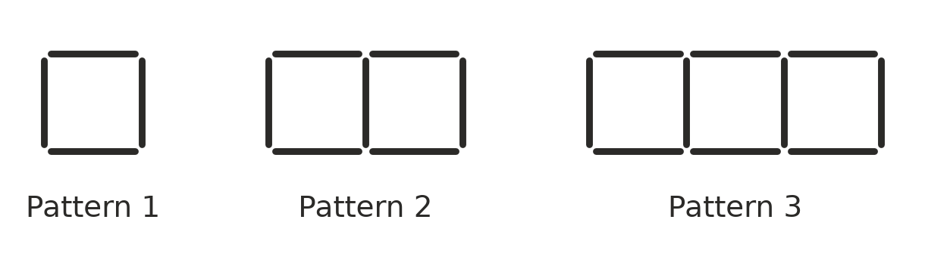
Number of squares, $s$ | 1 | 2 | 3 | 4 | 5
Number of matchsticks, $M$ | 4 | 7 | 10

  - Copy and complete the table.
  - The rule for the pattern is $M=3s+1$. Check that the rule works for 2 squares.
  - Use the rule to find the number of matchsticks needed for 10 squares.
- The cost in dollars of hiring a jumping castle for $h$ hours is $C=40h+30$.
  - Find the cost for 2 hours.
  - Find the cost for 5 hours.
- At a church lunch, the number of chairs needed for $t$ tables is $c=6t$.
  - How many chairs are needed for 8 tables?
  - How many chairs are needed for 15 tables?
- The area of a rectangle is $A=lw$, where $l$ is the length and $w$ is the width. Find the area of a rectangular vegetable garden that is 9 m long and 4 m wide.

