8.01 Introduction to variables
Year 7 Maths · Worksheet · Level 2 · Core
Name: ____________________ Date: ______________
This worksheet practises using variables (letters that stand for numbers) and writing algebra the short way. Tip: leave out the × sign, put the number first and the letters in alphabetical order, so $b×3×a$ is written $3ab$, and $k×k$ is written $k^{2}$.

 Understanding
- Write true or false for each statement.
  - In $7k$, the variable is $k$. ______________
  - $5×y$ is written $y5$. ______________
  - $m+m=2m$ ______________
  - $a×b$ can be written as $ab$. ______________
  - $x+x+x=3x$ ______________
  - $n×n=2n$ ______________
- Each box holds $p$ counters and each bag holds $b$ counters. Write an expression for the total number of counters in each picture.
- 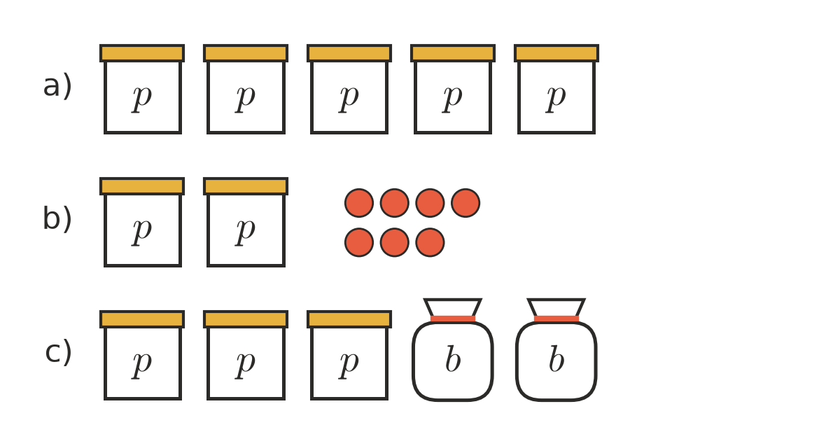
  - ______________
  - ______________
  - ______________

 Fluency
- Write each of these in the short way, without × signs.
  - $8×d$ = ______________
  - $q×3$ = ______________
  - $a×6×b$ = ______________
  - $2×m×7$ = ______________
  - $y×x$ = ______________
  - $k×k$ = ______________
  - $4×h×h$ = ______________
  - $r×s×3×t$ = ______________
- Write each of these as a fraction, without the ÷ sign.
  - $m÷6$ = ______________
  - $20÷c$ = ______________
  - $(a+3)÷4$ = ______________
- Write each of these in full, using + or × signs.
  - $3g$ = ______________
  - $5ab$ = ______________
  - $2y^{2}$ = ______________
- Movie tickets cost $15 each.
Number of tickets | 1 | 2 | 5 | 12 | $n$
Cost ($) | 15

  - Complete the table.
  - Write a formula for the cost $C$ of $n$ tickets. $C$ = ______________
- Write a formula for each of these.
  - The number of wheels $W$ on $c$ cars. ______________
  - The number of legs $L$ on $s$ spiders. ______________
  - The number of minutes $M$ in $h$ hours. ______________
  - The number of days $D$ in $w$ weeks. ______________

 Reasoning
- Explain the difference between $4m$ and $m+4$. Use $m=10$ to show that they are different.

- Which expression means the same as $a+a+a+b+b$? Answer: ______________
  - $3a2b$
  - $3a+2b$
  - $5ab$
  - $a^{3}+b^{2}$
- Is $ab$ the same as $ba$? Explain, and test your answer with $a=3$ and $b=4$.

 Problem solving
- At the canteen, sausage rolls cost $3 each and drinks cost $2 each.
  - Write an expression for the cost of $r$ sausage rolls. ______________
  - Write an expression for the cost of $d$ drinks. ______________
  - Write an expression for the total cost of $r$ sausage rolls and $d$ drinks. ______________
  - Find the cost of 4 sausage rolls and 3 drinks. ______________
- A farmer has $c$ cows and $h$ hens.
  - Write an expression for the total number of legs. ______________
  - Write an expression for the total number of heads. ______________
  - The farmer has 6 cows and 10 hens. How many legs are there altogether? ______________

