8.01 Introduction to variables
Year 7 Maths · Worksheet · Level 1 · Warm-up
Name: ____________________ Date: ______________
This worksheet practises using letters to stand for numbers. A letter used this way is called a variable. Tip: in algebra we leave out the × sign and write the number first, so $3×n$ is written $3n$.

 Understanding
- Write the variable in each expression.
  - $n+6$ ______________
  - $4k$ ______________
  - $15−y$ ______________
  - $\frac{w}{3}$ ______________
- Each bag holds the same number of lollies, $n$. Write an expression for the total number of lollies in each picture.
- 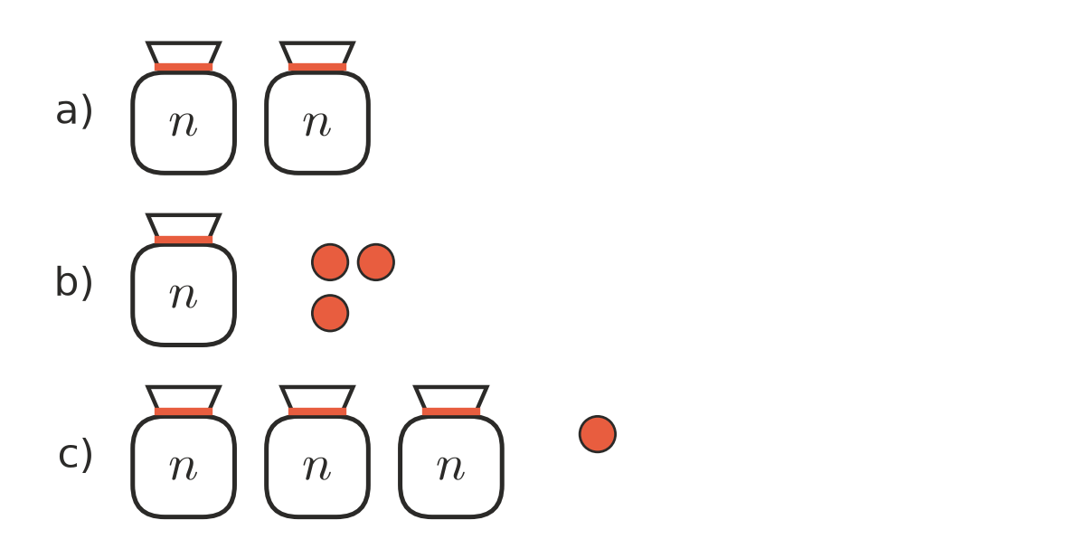
  - ______________
  - ______________
  - ______________
- Complete each statement.
  - $n+n+n$ = ______________
  - $a+a$ = ______________
  - $4×k$ = ______________
  - $m×5$ = ______________
  - $1×p$ = ______________
  - $x×y$ = ______________

 Fluency
- Write each of these without the × sign.
  - $6×t$ = ______________
  - $y×2$ = ______________
  - $3×a×b$ = ______________
  - $c×7×d$ = ______________
  - $w×1$ = ______________
  - $2×5×m$ = ______________
- Write each of these as a fraction, without the ÷ sign.
  - $n÷2$ = ______________
  - $x÷5$ = ______________
  - $12÷a$ = ______________
- Write each of these as a sum using + signs.
  - $4b$ = ______________
  - $2c$ = ______________
  - $5m$ = ______________
- A pie at the school canteen costs $4. Complete the table.
Number of pies | 1 | 2 | 3 | 10 | $n$
Cost ($) | 4

 Reasoning
- Mia says that $3n$ and $n+3$ mean the same thing. Is she right? Use $n=5$ to explain.

- Which is the correct way to write $p×4$? Answer: ______________
  - $p4$
  - $4p$
  - $4+p$
  - $p+4$

 Problem solving
- A square has sides that are $s$ cm long.
  - Write the perimeter of the square using + signs. ______________
  - Write the perimeter the short way, without + signs. ______________
  - What is the perimeter when each side is 6 cm? ______________
- Ben is $b$ years old. His sister is 3 years older than Ben. His dad is 4 times as old as Ben.
  - Write an expression for his sister’s age. ______________
  - Write an expression for his dad’s age. ______________
  - Ben is 9. How old is his dad? ______________

