8.01 Introduction to variables
Year 7 Maths · A5 question sheet · Level 2 · Core
This worksheet practises using variables (letters that stand for numbers) and writing algebra the short way. Tip: leave out the × sign, put the number first and the letters in alphabetical order, so $b×3×a$ is written $3ab$, and $k×k$ is written $k^{2}$.

 Understanding
- Write true or false for each statement.
  - In $7k$, the variable is $k$.
  - $5×y$ is written $y5$.
  - $m+m=2m$
  - $a×b$ can be written as $ab$.
  - $x+x+x=3x$
  - $n×n=2n$
- Each box holds $p$ counters and each bag holds $b$ counters. Write an expression for the total number of counters in each picture.
  - 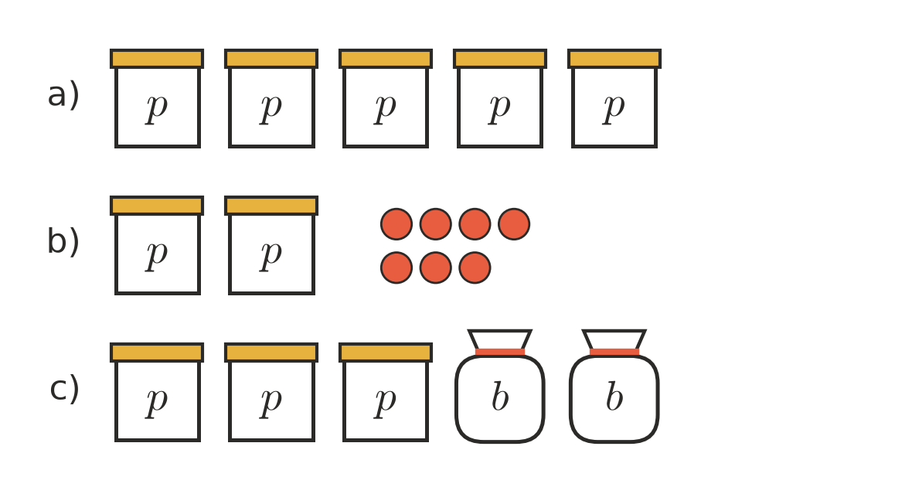

 Fluency
- Write each of these in the short way, without × signs.
  - $8×d$ =
  - $q×3$ =
  - $a×6×b$ =
  - $2×m×7$ =
  - $y×x$ =
  - $k×k$ =
  - $4×h×h$ =
  - $r×s×3×t$ =
- Write each of these as a fraction, without the ÷ sign.
  - $m÷6$ =
  - $20÷c$ =
  - $(a+3)÷4$ =
- Write each of these in full, using + or × signs.
  - $3g$ =
  - $5ab$ =
  - $2y^{2}$ =
- Movie tickets cost $15 each.
Number of tickets | 1 | 2 | 5 | 12 | $n$
Cost ($) | 15

  - Copy and complete the table.
  - Write a formula for the cost $C$ of $n$ tickets. $C$ =
- Write a formula for each of these.
  - The number of wheels $W$ on $c$ cars.
  - The number of legs $L$ on $s$ spiders.
  - The number of minutes $M$ in $h$ hours.
  - The number of days $D$ in $w$ weeks.

 Reasoning
- Explain the difference between $4m$ and $m+4$. Use $m=10$ to show that they are different.
- Which expression means the same as $a+a+a+b+b$?
  - $3a2b$
  - $3a+2b$
  - $5ab$
  - $a^{3}+b^{2}$
- Is $ab$ the same as $ba$? Explain, and test your answer with $a=3$ and $b=4$.

 Problem solving
- At the canteen, sausage rolls cost $3 each and drinks cost $2 each.
  - Write an expression for the cost of $r$ sausage rolls.
  - Write an expression for the cost of $d$ drinks.
  - Write an expression for the total cost of $r$ sausage rolls and $d$ drinks.
  - Find the cost of 4 sausage rolls and 3 drinks.
- A farmer has $c$ cows and $h$ hens.
  - Write an expression for the total number of legs.
  - Write an expression for the total number of heads.
  - The farmer has 6 cows and 10 hens. How many legs are there altogether?

