8.01 Introduction to variables
Year 7 Maths · A5 question sheet · Level 1 · Warm-up
This worksheet practises using letters to stand for numbers. A letter used this way is called a variable. Tip: in algebra we leave out the × sign and write the number first, so $3×n$ is written $3n$.

 Understanding
- Write the variable in each expression.
  - $n+6$
  - $4k$
  - $15−y$
  - $\frac{w}{3}$
- Each bag holds the same number of lollies, $n$. Write an expression for the total number of lollies in each picture.
  - 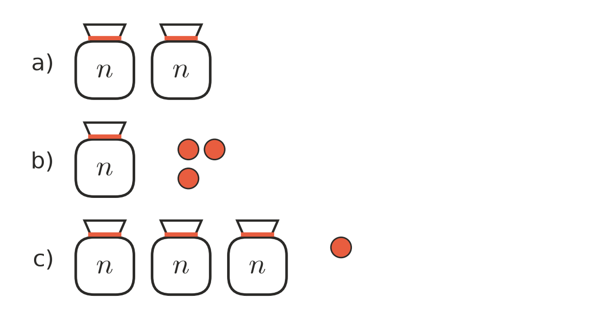

- Complete each statement.
  - $n+n+n$ =
  - $a+a$ =
  - $4×k$ =
  - $m×5$ =
  - $1×p$ =
  - $x×y$ =

 Fluency
- Write each of these without the × sign.
  - $6×t$ =
  - $y×2$ =
  - $3×a×b$ =
  - $c×7×d$ =
  - $w×1$ =
  - $2×5×m$ =
- Write each of these as a fraction, without the ÷ sign.
  - $n÷2$ =
  - $x÷5$ =
  - $12÷a$ =
- Write each of these as a sum using + signs.
  - $4b$ =
  - $2c$ =
  - $5m$ =
- A pie at the school canteen costs $4. Copy and complete the table.
Number of pies | 1 | 2 | 3 | 10 | $n$
Cost ($) | 4

 Reasoning
- Mia says that $3n$ and $n+3$ mean the same thing. Is she right? Use $n=5$ to explain.
- Which is the correct way to write $p×4$?
  - $p4$
  - $4p$
  - $4+p$
  - $p+4$

 Problem solving
- A square has sides that are $s$ cm long.
  - Write the perimeter of the square using + signs.
  - Write the perimeter the short way, without + signs.
  - What is the perimeter when each side is 6 cm?
- Ben is $b$ years old. His sister is 3 years older than Ben. His dad is 4 times as old as Ben.
  - Write an expression for his sister’s age.
  - Write an expression for his dad’s age.
  - Ben is 9. How old is his dad?

