Skill 2: Map skills on the Nile
Year 7 HASS · Worksheet
Name: ____________________ Date: ______________
A map is a source too: it can show at a glance why Egypt grew up where it did. This sheet teaches you how to read a map properly, using grid references, directions and a scale bar.

How it works

BOLTSS: what every good map needs
Letter | Stands for | What it does
B | Border | a frame around the edge of the map
O | Orientation | a north arrow, so you know which way is north
L | Legend | a key that explains the symbols and colours
T | Title | says what the map shows, and where
S | Scale | shows how distance on the map compares with real distance
S | Source | says who made the map or where the information came from

Grid references
The map is divided into squares. The columns have letters (A to F) along the top and bottom. The rows have numbers (1 to 6) down the sides.
- Find the place on the map.
- Look straight up or down to find its letter.
- Look straight across to find its number.
- Write the letter first, then the number, for example C1.
Tip: “Along the corridor, then up the stairs.” Letter first, always.

Compass directions
There are eight main directions: north (N), north-east (NE), east (E), south-east (SE), south (S), south-west (SW), west (W) and north-west (NW). Always give a direction from one place to another. Imagine standing at the first place, facing north: which way would you walk?

Using the scale bar
- Lay the straight edge of a strip of paper between the two places. Make a mark at each one.
- Move the strip to the scale bar and put the first mark at 0.
- Read off where the second mark falls. If it goes past the end of the bar, mark 300 km on the strip, slide the strip along and keep counting.
- Give your answer as an estimate, such as “about 500 km”.

Worked example

Map: Ancient Egypt and the River Nile
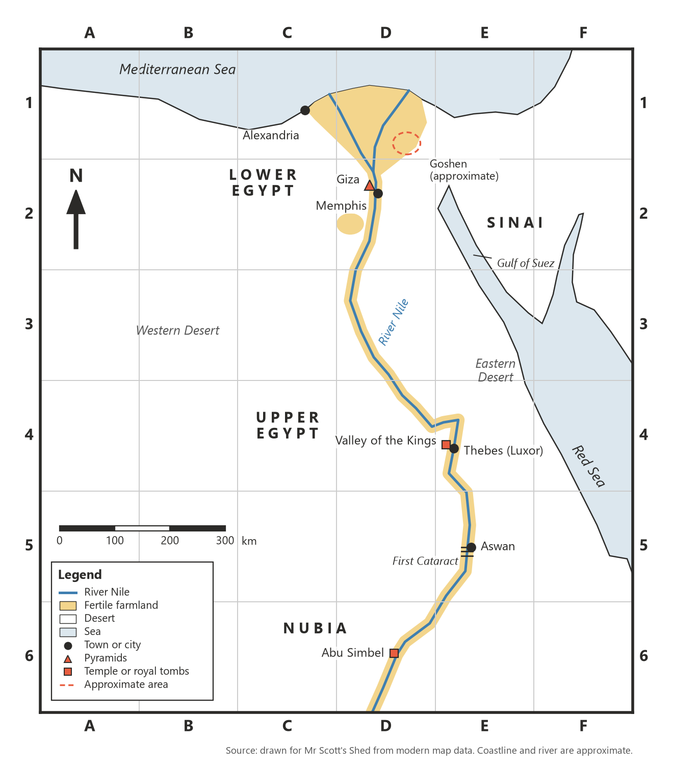
Map 1: Egypt and the Nile. The coastline and river follow modern maps and are approximate.
BOLTSS check. Border: the thick black frame. Orientation: the north arrow in square A2. Legend: the box at the bottom left. Title: the heading above the map. Scale: the bar marked 0 to 300 km. Source: the line under the map. This map has all six.
Grid reference of Alexandria. Find the dot for Alexandria on the coast. Look straight up: column C. Look across: row 1. Answer: C1.
Direction from Alexandria to Giza. Stand at Alexandria facing north. Giza is down the page (south) and to the right (east). Answer: Giza is south-east of Alexandria.
Distance from Alexandria to Giza. Mark both dots on a strip of paper and lay it on the scale bar. The second mark lands a little short of 200 km. Answer: about 180 km.

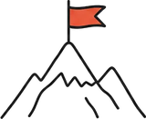 Your turn

Guided practice
- Give the grid reference of each place. The first one is started for you.
Place | Grid reference
Giza | D ______________
Thebes (Luxor)
Aswan
Abu Simbel
Goshen (approximate)

- What is found in each square?
  - E2 ______________
  - C6 ______________
  - B3 ______________
- Complete each direction.
  - From Giza to Goshen is north-______________
  - From Aswan to Abu Simbel is ______________
  - From Giza to the Sinai is ______________
  - From Thebes to the Red Sea is ______________
- Use the scale bar to estimate each distance in a straight line.
  - Thebes to Aswan: about ______________ km
  - Giza to Thebes: about ______________ km
  - Aswan to Abu Simbel: about ______________ km

On your own
- Which way does the Nile flow: north to south, or south to north? How can you tell from Map 1? (Hint: rivers flow into the sea.)

- Explain why Upper Egypt is in the south of the map and Lower Egypt is in the north. (Hint: think about which end of a river is “up”.)

- In Egypt the wind usually blows from the north, towards the south. The Egyptian hieroglyph for “travel south” was a boat with its sail up, and the sign for “travel north” was a boat with its sail down. Use the map to explain why.

- What does Map 1 show about where people lived in ancient Egypt? Use the legend and at least two places on the map as evidence.

- The Western Desert and the Eastern Desert lie on both sides of the Nile valley. Give one way the deserts helped Egypt and one way they made life hard.

- Label the blank map below.
  - Write the name next to each place symbol: Alexandria, Giza, Memphis, Thebes (Luxor), Valley of the Kings, Aswan and Abu Simbel.
  - Label the Mediterranean Sea, the Red Sea, the River Nile and the Sinai.
  - Write UPPER EGYPT and LOWER EGYPT in the right places.
  - Shade the fertile farmland along the Nile and in the Delta.
  - Complete the legend, and write a title above the map.
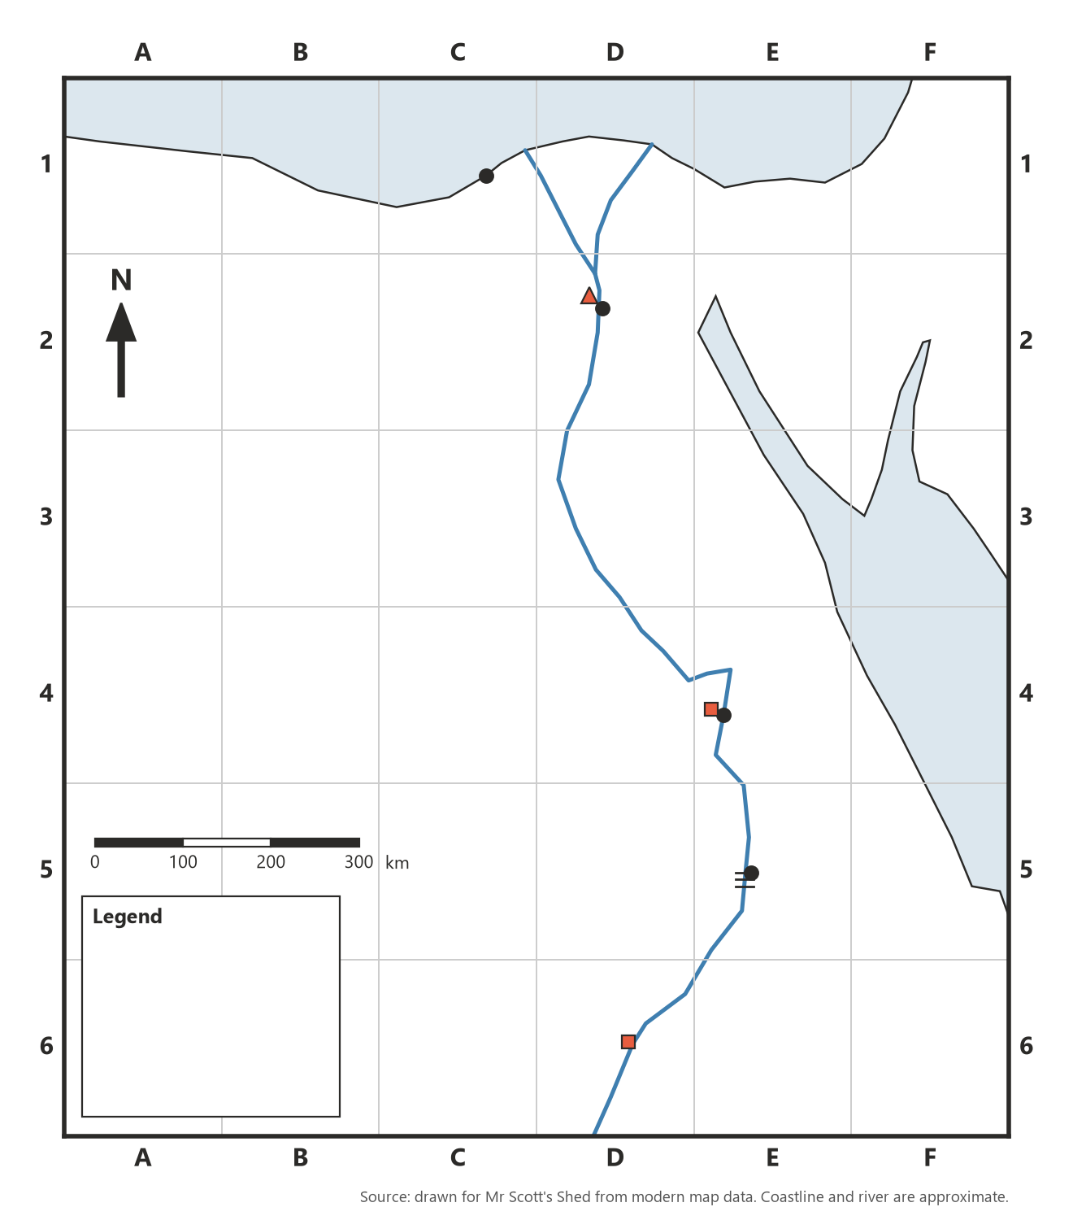
- Which BOLTSS features did the blank map already have, and which did you add?

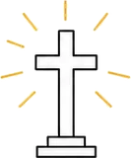 Faith connection
“Now the Israelites settled in the land of Egypt, in the region of Goshen. They acquired property there and became fruitful and increased greatly in number.” (Genesis 47:27)
When the Magi had gone, an angel of the Lord appeared to Joseph in a dream. “Get up!” he said. “Take the Child and His mother and flee to Egypt. Stay there until I tell you, for Herod is going to search for the Child to kill Him.” So he got up, took the Child and His mother by night, and withdrew to Egypt, where he stayed until the death of Herod. This fulfilled what the Lord had spoken through the prophet: “Out of Egypt I called My Son.” (Matthew 2:13–15)
Look at the map again. Egypt sits right next door to Canaan, the land of Israel, and the green Delta is the first rich land a traveller from Canaan reaches. When famine struck, Abraham and later Jacob’s whole family went down to Egypt for food, and Jacob’s family settled in Goshen. Many centuries later, Joseph and Mary carried the baby Jesus to Egypt to escape King Herod. Egypt was a place of refuge.
But Egypt was also the place where Israel became slaves, and where God rescued them in the Exodus. The Bible tells both stories honestly. Christians believe God was with his people in both places: giving them food and safety, and hearing them when they cried out.
- Find Goshen on Map 1. Why would the eastern Delta have been a good place for a family of shepherds arriving from Canaan?

- Why do you think Egypt was a place of refuge and a place of slavery in the Bible’s story? What does that show about God?

