Skill 1: The source box
Year 7 HASS · A5 question sheet
Historians can’t travel back in time, so they question the sources the past left behind. This sheet teaches you five questions to ask any source, so you can work out what it tells us and what it is useful for.

How it works

Primary and secondary sources
Kind of source | What it is | Examples from Egypt
Primary source | made at the time, by people who lived through it or saw it | a mummy, a tomb painting, a letter on papyrus, Tutankhamun’s gold mask
Secondary source | made later, by people looking back at the past | a textbook, a documentary, a museum sign, this worksheet

Sometimes it depends on your question. The Greek traveller Herodotus visited Egypt about 450 BCE. For how Egyptians made mummies in his own day, his book is a primary source: he was there and talked to the people. For the building of the pyramids, more than 2000 years before he was born, it is a secondary source: he could only repeat what he was told.

The source box
Ask these five questions about every source.
Question | What to think about
1. What is it? | An object, a picture or a piece of writing? Primary or secondary?
2. Who made it, and when? | The maker (if we know), the date (often “about”), and whether they were there
3. Why was it made? | To record, to praise, to worship, to protect, to teach, to persuade?
4. What does it tell us? | What you can see or read, and what you can work out (infer) from it
5. How useful is it, and for what? | Which questions it helps answer, and what it can’t tell us

Two big ideas about trust
- Every source is useful for something. A carving that boasts about a pharaoh’s victory may not tell us exactly what happened in the battle, but it tells us how the pharaoh wanted to be seen. So don’t just ask “Is it useful?” Ask “Useful for what?”
- Perspective is not the same as lying. Everyone sees from where they stand. A slave and a king would describe the same building project very differently, and both could be telling the truth as they lived it. A good historian notices the perspective and compares sources.

Worked example
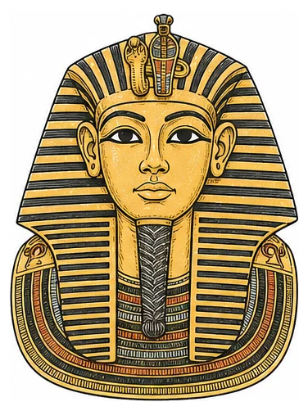
Source A: a drawing of the gold funeral mask of Tutankhamun.
Here is the source box for the mask, filled in the way a good answer looks. The picture is a modern drawing, but the box is about the real mask.
Question | Answer
What is it? | A funeral mask made of gold (about 10 kg), inlaid with blue lapis lazuli, coloured glass and other stones. It is a primary source: an artefact from the time.
Who made it, and when? | Skilled royal craftsmen whose names we don’t know, about 1323 BCE, for the burial of the young pharaoh Tutankhamun. Howard Carter’s team found it on the king’s mummy in 1925.
Why was it made? | To protect the king’s head and give him a perfect, everlasting face for the afterlife. A protective spell from the Book of the Dead is carved on the back.
What does it tell us? | The king wears the striped nemes headcloth and a false beard, signs of a king who is like a god. On his brow are a cobra and a vulture, the goddesses of Lower and Upper Egypt, so he ruled both lands. The gold and stones show great wealth and long-distance trade: lapis lazuli came from what is now Afghanistan.
How useful is it, and for what? | Very useful for royal wealth, craft skill, and beliefs about kings and the afterlife. Less useful for what Tutankhamun really looked like, because the face is made perfect. It tells us almost nothing about how ordinary farmers lived.

Notice that the last answer says what the source is useful for, and also what it can’t tell us.

 Your turn

Guided practice: Herodotus on mummies
Source B: Herodotus, a Greek historian who visited Egypt about 450 BCE, Histories, Book 2 (adapted)
There are men in Egypt whose trade is embalming. In the most costly method, they first draw out the brain through the nostrils with an iron hook. Then they cut open the side with a sharp stone and take out everything in the belly. They clean the inside, rinse it with palm wine and spices, fill it with myrrh and other sweet spices, and sew it up again. Next they cover the body in natron, a kind of salt, for seventy days, and no longer. After this they wash the body and wrap it from head to foot in strips of fine linen, smeared with gum. Then the family take the body home and shut it in a wooden case shaped like a person.
- What is it? Finish the sentence.
- Source B is part of ______________ It is a (primary / secondary) source for how mummies were made in 450 BCE, because
- Who made it, and when? The Great Pyramid was finished about 2560 BCE. About how many years later did Herodotus visit Egypt? Show your working.
- Why was it made? Herodotus said he wrote so that the great deeds of Greeks and other peoples would not be forgotten. Why do you think he described this Egyptian custom in so much detail for Greek readers?
- What does it tell us? List three steps of mummification from Source B, in order.

- How useful is it, and for what? Read this information, then answer.
- Modern CT scans of mummies show that the brain was often removed through the nose, just as Herodotus says. But most experts think the body was dried in natron for about 40 days, and that 70 days was the time for the whole process.
  - Name one thing Herodotus got right and one thing he may have got wrong.
  - Is Source B more useful for learning about mummies in 450 BCE, or about how the pyramids were built? Explain.

On your own: a source from the Bible
The book of Exodus is part of the Bible. For Jewish people and Christians it is sacred: Israel’s own account of how God rescued them from slavery in Egypt. It is written from the perspective of the enslaved, which is rare in the ancient world, where most records were made for kings. Jewish and Christian tradition links Exodus with Moses; scholars debate when it was written down. Christians and historians also date these events differently.
Source C: Exodus 1:8–14 (Berean Standard Bible)
Then a new king, who did not know Joseph, came to power in Egypt. “Look,” he said to his people, “the Israelites have become too numerous and too powerful for us. Come, let us deal shrewdly with them, or they will increase even more; and if a war breaks out, they may join our enemies, fight against us, and leave the country.” So the Egyptians appointed taskmasters over the Israelites to oppress them with forced labor. As a result, they built Pithom and Rameses as store cities for Pharaoh. But the more they were oppressed, the more they multiplied and flourished; so the Egyptians came to dread the Israelites. They worked the Israelites ruthlessly and made their lives bitter with hard labor in brick and mortar, and with all kinds of work in the fields. Every service they imposed was harsh.
- Complete the source box for Source C.
Question
What is it?
Who made it, and when?
Why was it made?
What does it tell us?
How useful is it, and for what?

- According to Source C, why did the new king fear the Israelites? Give two reasons.
- Imagine an Egyptian official wrote a report about the same building work. How might his account be different? Does that mean one of them must be lying? Explain.
- Historians have not yet found an Egyptian record that names Israelite slaves. But a painting in the tomb of an official named Rekhmire (about 1450 BCE) shows foreign workers making mud bricks under Egyptian overseers. How could a historian use this painting alongside Source C?

On your own: a picture of the afterlife
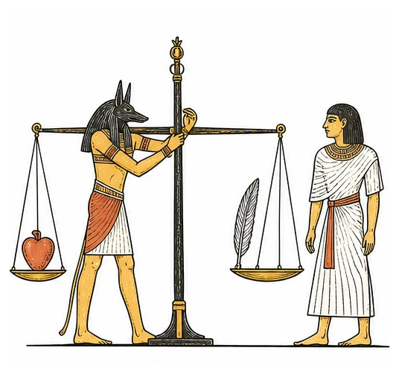
Source D: a modern drawing based on scenes painted in Egyptian Book of the Dead scrolls, such as the Papyrus of Hunefer (about 1300 BCE).
In the real scrolls, the jackal-headed god Anubis weighs the dead person’s heart against the feather of Ma’at, the goddess of truth and justice. The god Thoth writes down the result, and a monster called Ammit waits to eat any heart that is too heavy with wrongdoing.
- Complete the source box for Source D. Remember: the drawing is modern, but it copies an ancient source.
Question
What is it?
Who made it, and when?
Why was it made?
What does it tell us?
How useful is it, and for what?

- Nobody ever saw this scene happen. Is Source D still a useful source? Explain what it is useful for.

 Faith connection
“I have indeed seen the affliction of My people in Egypt. I have heard them crying out because of their oppressors, and I am aware of their sufferings.” (Exodus 3:7)
Most of what survives from ancient Egypt was made for kings, priests and officials. Their monuments tell their side of the story. Source C is different. It remembers the bricks, the mortar and the bitter work from the side of the people who suffered, and Exodus goes on to say that God saw it all. Christians believe the Bible is God’s true word, and part of its truth is that God notices people whom history usually forgets.
Source D shows a very different hope. Egyptians hoped their hearts would be light enough to pass the test on the scales. The Bible teaches that no one is saved by passing a test: “For it is by grace you have been saved through faith, and this not from yourselves; it is the gift of God, not by works, so that no one can boast.” (Ephesians 2:8–9)
- Exodus 3:7 says God saw and heard people that Pharaoh treated as unimportant. Why does it matter that a source tells the story from the side of the weak? What does this verse show about God?

