Reading 5: Trade, war and peace
Year 7 HASS · A5 question sheet
Egypt was protected by deserts, but it was never cut off from the world. This reading looks at how Egypt traded, fought and made peace with its neighbours, and how in the end it was conquered.

 Key words
Word | Meaning
trade | buying, selling or swapping goods
expedition | a long journey made for a special purpose
chariot | a light two-wheeled cart pulled by horses, used in war
empire | a group of lands ruled by one powerful ruler or country
propaganda | information made to persuade people, often by showing only one side
treaty | a written agreement between countries
cuneiform | wedge-shaped writing pressed into clay tablets, used in western Asia
conquest | taking control of a land by force

Read

What Egypt lacked
The Nile gave Egypt plenty of grain, but some things it could not grow or dig up. Egypt had almost no tall trees, so it brought in cedar logs from Lebanon, on the coast to the north-east, for ships, coffins and temple doors. One early king, Sneferu, is recorded as bringing back forty shiploads of cedar.
To the south lay Nubia (in today’s Sudan). Nubia was rich in gold, ivory, ebony wood and animal skins. Egypt traded with Nubia, raided it and, in the New Kingdom, conquered it. Nubian gold helped pay for Egypt’s temples and tombs.

Hatshepsut’s ships to Punt
About 1470 BCE, the female pharaoh Hatshepsut sent five ships down the Red Sea to the land of Punt, probably on the coast of East Africa. The expedition came home loaded with treasure, and Hatshepsut had the whole journey carved on the walls of her temple at Deir el-Bahari.
Source A: words carved beside the pictures of the Punt expedition in Hatshepsut’s temple, about 1470 BCE (adapted)
The ships were loaded very heavily with the marvels of the land of Punt: sweet-smelling woods, heaps of myrrh and fresh myrrh trees, ebony and pure ivory, gold, incense, eye paint, baboons, monkeys, dogs and the skins of leopards. Never was anything like this brought for any king since the world began.
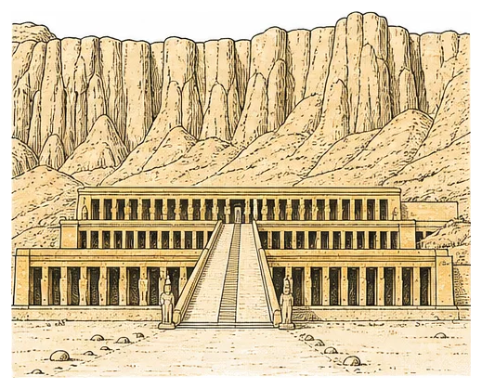
Hatshepsut’s temple at Deir el-Bahari, where the Punt expedition is shown.

Invaders with chariots
Egypt’s deserts did not always keep enemies out. About 1650 BCE, people from western Asia called the Hyksos took control of northern Egypt. They had horses and chariots, which were new to Egypt. The Egyptians learned from them. About 1550 BCE, King Ahmose used chariots to drive the Hyksos out, and the New Kingdom began.
Never again did Egypt want to be caught unready. New Kingdom pharaohs built a large army and an empire stretching from Nubia in the south to Syria in the north.

The Battle of Kadesh
In Syria, Egypt met another great power: the Hittites, from what is now Turkey. In 1274 BCE, Ramesses II marched north to the city of Kadesh. Two captured spies told him the Hittite army was far away. It was a trick. The Hittites were hiding behind the city, and their chariots smashed into the Egyptian camp. Ramesses fought back bravely until more of his troops arrived. In the end, neither side won clearly, and Kadesh stayed in Hittite hands.
You would never guess this from Ramesses’ own version. He had the battle carved on temple walls all over Egypt as a great victory.
Source B: Ramesses II’s account of the battle, carved on several temples (adapted)
My soldiers and my chariot drivers abandoned me; not one of them stood with me. I called out to my father Amun, and he answered me. I charged at the enemy like the god of war. I was alone, and their 2500 chariots fell before my horses.

Peace at last
The wars dragged on. Then, about 1259 BCE, Ramesses II and the Hittite king Hattusili III made a treaty: one of the earliest peace treaties whose words survive. They promised never to attack each other again, to help each other against enemies, and to send back runaways without punishing them.
Source C: from the treaty between Egypt and the Hittites, about 1259 BCE (adapted)
There shall be no war between them forever. The great king of the Hittites shall never enter the land of Egypt to take anything from it, and Ramesses shall never enter the land of the Hittites to take anything from it.
Copies survive in both lands: carved in hieroglyphs on Egyptian temples, and pressed in cuneiform into clay tablets found in the Hittite capital. A large copy of one tablet hangs at the United Nations in New York, as an example of peace-making.

The end of independence
Egypt’s power slowly faded. It was conquered by the Persians in 525 BCE, and by Alexander the Great in 332 BCE. Greek kings descended from his general Ptolemy then ruled Egypt for three centuries. When Queen Cleopatra died in 30 BCE, Egypt became part of the Roman Empire.

 Questions
- Copy and complete the table to show where Egypt got each item.
Item
cedar wood
gold and ivory
myrrh trees

- Why did Egypt need to trade for cedar wood?
- Use Source A.
  - List three things the expedition brought back.
  - Why do you think Hatshepsut wanted the journey carved on her temple walls?
- Explain how the Hyksos invasion changed the way Egypt fought wars.
- Number these events from 1 to 5 in the order they happened.
Event
Alexander the Great takes Egypt.
Ramesses II fights the Battle of Kadesh.
Ahmose drives out the Hyksos.
Egypt becomes part of the Roman Empire.
Egypt and the Hittites sign a peace treaty.

- Use Source B and the reading.
  - How does Ramesses describe his part in the battle?
  - Why do historians call Source B propaganda?
- Use Source C. Name two promises the two kings made to each other.
- Why is it useful to historians that copies of the treaty survive from both sides?

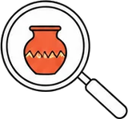 Think like a historian
- How reliable is Source B as evidence of what happened at Kadesh? Explain who made it, why, and what other evidence historians can check it against.

 Faith connection
“In the fifth year of Rehoboam’s reign, Shishak king of Egypt attacked Jerusalem. He seized the treasures of the house of the LORD and of the royal palace. He took everything, including all the gold shields that Solomon had made.” (1 Kings 14:25–26)
“Blessed are the peacemakers, for they will be called sons of God.” (Matthew 5:9)
The Bible’s story crosses paths with Egypt’s wars. After Solomon’s death, a pharaoh called Shishak raided Jerusalem. Most historians identify him with Shoshenq I, who carved a list of towns he attacked in Canaan on a temple wall at Karnak.
The Bible is honest that the world is full of war. Yet it looks forward to a day when God will judge between nations and people “will beat their swords into plowshares” (Isaiah 2:4). Jesus called peacemakers blessed. Ramesses and Hattusili made peace for their kingdoms’ sake; Christians believe God himself made peace with people through Jesus, and calls his followers to be peacemakers too.
- Ramesses boasted about war, but Jesus said, “Blessed are the peacemakers.” What is one way a Year 7 student can be a peacemaker at school, at home or online?
- Isaiah 2:4 pictures swords being beaten into plowshares (ploughs). What do you think this picture means?

