Reading 4: Gods, death and the afterlife
Year 7 HASS · A5 question sheet
The Egyptians spent a great deal of time, money and skill getting ready for death. This reading explores what they believed about the gods and the afterlife, which is the second half of our big question.

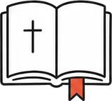 Key words
Word | Meaning
afterlife | life after death
ma’at | the Egyptian idea of truth, justice and right order; also a goddess
temple | a building where a god was believed to live and be served by priests
embalmer | a person who prepared dead bodies for burial
natron | a natural salt used to dry out a body
canopic jars | four jars that held a mummy’s preserved organs
Book of the Dead | a collection of spells written on papyrus to help the dead reach the afterlife
resurrection | rising from the dead to a new life in the body

Read

A world full of gods
The Egyptians worshipped hundreds of gods. Ra, the sun god, sailed across the sky each day in a boat. Osiris ruled the land of the dead. The stories said he was killed by his jealous brother Set, then brought back to life by his wife Isis, a powerful protector. Their son Horus, shown with a falcon’s head, was the god of kingship: each pharaoh was called the “living Horus”. Anubis, with the head of a jackal, watched over embalming and guided the dead.
Behind all of them stood ma’at: truth, justice and order. The pharaoh’s most important job was to keep ma’at, so that the sun rose, the Nile flooded and the land had peace.
Each god was believed to live in its temple, inside a statue in a dark inner room. Every morning, priests washed the statue, dressed it and offered it food. Ordinary people could not go inside; they prayed at the gates or at small shrines at home.

Getting ready for forever
Egyptians believed a person’s spirit needed their body in the afterlife, so the body had to be kept from rotting. The most famous description of how this was done comes from the Greek visitor Herodotus.
Source A: Herodotus, a Greek historian who visited Egypt, writing about 440 BCE (adapted)
First they draw out the brain through the nostrils with an iron hook. Then they cut open the side with a sharp stone and take out all the insides. They clean the body with palm wine and spices, fill it with myrrh and other sweet spices, and sew it up. Then they cover it with natron for seventy days, and no longer. After this they wash the body and wrap the whole of it in bandages of fine linen, smeared with gum. Then the family takes it home and places it in a wooden case shaped like a person.
Modern scientists, studying real mummies, think the drying took about 40 days and the whole process about 70. The lungs, liver, stomach and intestines were dried and stored in four canopic jars. Their lids were often shaped like the heads of four protector gods: a human, a baboon, a jackal and a falcon. The heart was usually left in the body, because Egyptians believed it was where a person thought and chose.
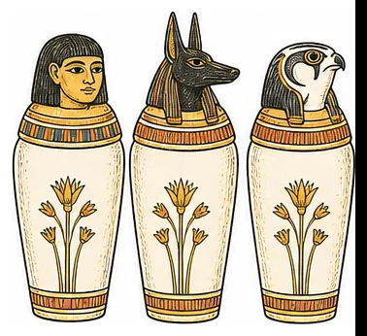
Three of the four canopic jars, with human, jackal and falcon lids. The fourth, with a baboon lid, is not shown.

The weighing of the heart
In the New Kingdom, people were buried with the Book of the Dead, a scroll of spells for the journey ahead. One spell describes the most important moment. The dead person stood in the hall of judgement and declared that they had done no evil:
Source B: from Spell 125 of the Book of the Dead, the “negative confession”, about 1550 BCE onwards (adapted)
I have not stolen. I have not killed. I have not told lies. I have not made anyone hungry. I have not made anyone cry. I have not taken milk from the mouths of children.
Then Anubis placed the person’s heart on one side of a balance and the feather of Ma’at on the other. If the heart was heavy with wrongdoing, a monster called Ammit, part crocodile, part lion and part hippopotamus, ate it, and the person was gone forever. If the heart balanced the feather, Osiris welcomed the person into the Field of Reeds, a perfect version of Egypt.
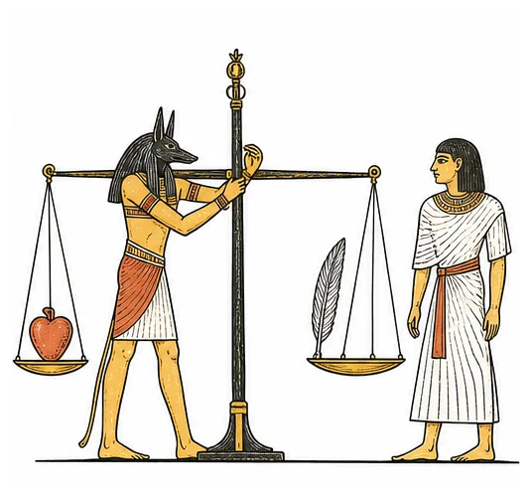
Anubis weighs a heart against the feather of Ma’at.

From pyramids to hidden tombs
Old Kingdom pharaohs were buried inside pyramids. The Great Pyramid of King Khufu at Giza, built about 2560 BCE, was the tallest building in the world for nearly 4000 years. But pyramids shouted “treasure here!” and robbers emptied them all. So New Kingdom pharaohs cut their tombs deep into the cliffs of a lonely valley near Thebes, now called the Valley of the Kings. More than 60 tombs have been found there. Most were still robbed in ancient times.

 Questions
- Match each god to the right description. Write the letter in the table.
  - jackal-headed god of embalming
  - the sun god
  - falcon-headed god of kingship
  - ruler of the land of the dead
  - wife of Osiris and a powerful protector
God
Ra
Osiris
Isis
Anubis
Horus

- What was ma’at, and why was it the pharaoh’s most important job to keep it?
- Why did Egyptians go to so much trouble to preserve the body?
- Use Source A. Put these steps of mummification in order, from 1 to 5.
Step
The body is wrapped in linen bandages.
The brain is removed through the nose.
The body is covered in natron.
The family places the body in a wooden case.
The insides are taken out and the body is cleaned.

- Herodotus says the body was covered in natron for seventy days. How do modern scientists’ findings differ from this? What does this teach us about using ancient sources?
- Why was the heart usually left inside the body?
- Use Source B and the picture. Describe what happened at the weighing of the heart, and what the two possible endings were.
- Why did New Kingdom pharaohs stop building pyramids and use the Valley of the Kings instead? Did the change work?

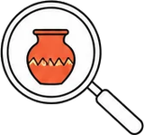 Think like a historian
- Source B is a list of things a person had not done. What does it tell us about what the Egyptians valued? Give two values and the evidence for each.

 Faith connection
“I am the LORD your God, who brought you out of the land of Egypt, out of the house of slavery. You shall have no other gods before Me.” (Exodus 20:2–3)
“Jesus said to her, ‘I am the resurrection and the life. Whoever believes in Me will live, even though he dies. And everyone who lives and believes in Me will never die. Do you believe this?’” (John 11:25–26)
“For it is by grace you have been saved through faith, and this not from yourselves; it is the gift of God, not by works, so that no one can boast.” (Ephesians 2:8–9)
The Egyptians took death seriously, and they longed for a good life after it. Christians share that longing, but believe something very different about how it comes. The Bible teaches that there is one true God, who judged “all the gods of Egypt” when he rescued Israel (Exodus 12:12).
In Egypt, a person hoped their heart would be light enough on the scales. The Bible teaches that no heart is light enough: everyone has done wrong. Instead, Jesus died for sinners and rose again, and he gives eternal life as a free gift to those who trust him. Christian hope does not rest on a perfect list of good deeds, but on the grace of God.
- Compare Egyptian hope for the afterlife with Christian hope. Give one way they are similar and one way they are different.
- Ephesians 2:8–9 says salvation is “not by works, so that no one can boast”. Why might this be good news for someone who knows they have done wrong?

