Reading 3: Who's who in ancient Egypt
Year 7 HASS · Worksheet
Name: ____________________ Date: ______________
A few Egyptians lived in palaces; most worked in the fields. This reading looks at the different groups in Egyptian society, what each one did and how their lives compared.

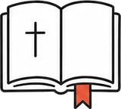 Key words
Word | Meaning
social pyramid | a diagram showing the groups in a society, from the most powerful at the top to the least powerful at the bottom
vizier | the pharaoh’s chief official, who ran the government
noble | a member of a rich and powerful family, often a governor or army leader
scribe | a trained writer who kept records
slave | a person who is owned by someone else and forced to work
ration | a fixed amount of food or goods given out as pay
strike | when workers stop working together to protest
ostracon | a broken piece of pottery or stone used to write on (plural: ostraca)

Read

The pyramid of power
Historians often picture Egyptian society as a pyramid. The Egyptians never drew it this way themselves; it is a simple model that helps us see who held power.
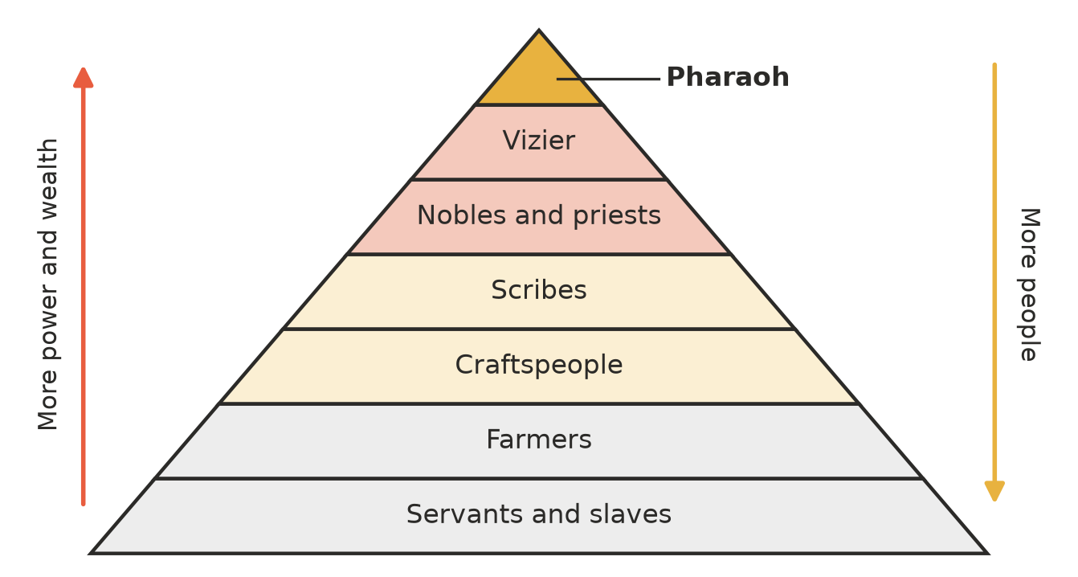
A model of Egyptian society. The groups near the top had the most power; the groups near the bottom had the most people.
At the top was the pharaoh. Egyptians believed he was a god on earth, the son of the sun god Ra. He owned the land, led the army and was expected to keep ma’at, the right order of the world.
Below him was the vizier, his chief official. The vizier collected taxes, judged important cases and met the pharaoh every day. Nobles governed the provinces and led armies. Priests ran the temples, which owned huge farms and workshops.

Scribes: the people who could write
Perhaps only one or two Egyptians in a hundred could read and write. Boys training as scribes spent years copying texts onto boards and ostraca. Scribes kept every record: taxes, harvests, court cases and building plans. It was a respected and comfortable job, and teachers made sure their students knew it.
Source A: from the Satire of the Trades, an Egyptian text in which a father takes his son to scribe school, written about 1900 BCE (adapted)
I have seen the metalworker at work at the mouth of his furnace. His fingers are like crocodile skin, and he stinks worse than fish eggs. … I will make you love writing more than your mother. … There is no job without a boss, except the scribe’s: he is the boss.

Hands and fields
Craftspeople included carpenters, stonemasons, painters, potters and jewellers. Below them were the farmers, by far the largest group. Most farmed land that belonged to the pharaoh, a temple or a noble, and paid part of every harvest as tax. During the flood, many were called up to work on canals, temples and pyramids.
At the bottom were servants and slaves. Many slaves were prisoners captured in war. Others had fallen into debt. They worked in homes, temples, fields and mines.

Women
Egyptian women had more rights than women in many ancient lands. They could own land and houses, buy and sell, make contracts, take a case to court and divorce their husbands, keeping their own property. Most women ran households; some were priestesses, weavers or musicians. Men held almost all government jobs, though a few women ruled, such as Hatshepsut.

The village of the tomb builders
At Deir el-Medina, near the Valley of the Kings, lived the skilled workers who cut and painted the royal tombs. Many of them could write, and thousands of their notes on ostraca survive: letters, shopping lists and records of who missed work and why. One man was away brewing beer; another had been stung by a scorpion.
The workers were paid in rations of grain, fish, vegetables and oil. About 1157 BCE, under Ramesses III, the rations were very late. The workers walked off the job and sat down behind a temple. It is the first strike in recorded history, and eventually they were paid.
Source B: the workers’ complaint, recorded on a papyrus now in Turin, Italy, about 1157 BCE (adapted)
We have come here because of hunger and thirst. We have no clothes, no oil, no fish and no vegetables. Write to Pharaoh, our good lord, and to the vizier, so that we may be given food.

Who built the pyramids?
Many films show slaves building the pyramids under whips. The evidence says otherwise. Archaeologists have found the town where the builders of the Giza pyramids lived, with bakeries, breweries and their own tombs close to the pyramids. The builders were Egyptians: skilled full-time workers, helped by farmers who took turns working for the king as a duty. They were fed bread, beer and meat. They were not slaves, though for many farmers the work was not a free choice.

 Questions
- Complete the table.
Group | One thing this group did
Pharaoh
Vizier
Priests
Scribes
Farmers

- Why is the social pyramid wide at the bottom and narrow at the top?

- Use Source A.
  - What does the father want his son to become?

  - Why might the father make other jobs sound worse than they really were?

- Give two rights that Egyptian women had, and one way their lives were still limited.

- Where did many slaves in Egypt come from?

- Use Source B and the reading.
  - Why did the workers of Deir el-Medina go on strike?

  - What does the strike tell us about how these workers saw themselves?

- Write true or false. If a statement is false, correct it.
Statement | True or false | Correction (if false)
The pyramids at Giza were built by slaves.
Most Egyptians were farmers.
The Egyptians drew the social pyramid themselves.

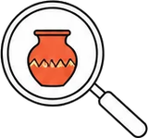 Think like a historian
- Perspective: how might a farmer and a scribe each have described their place in Egyptian society? Use evidence from the reading.

 Faith connection
“So God created man in His own image; in the image of God He created him; male and female He created them.” (Genesis 1:27)
“The LORD said, ‘I have indeed seen the affliction of My people in Egypt. I have heard them crying out because of their oppressors, and I am aware of their sufferings.’” (Exodus 3:7)
Egypt’s pyramid put one man at the top as a god. The Bible says something very different: every person, from the pharaoh to the slave in the mine, is made in God’s image and matters equally to him.
The Bible tells of both sides of Egyptian life. Joseph rose from slave to Pharaoh’s highest official and served him faithfully. Later, a new king forced the Israelites into “hard labor in brick and mortar” (Exodus 1:14). God did not ignore them. He saw, he heard, and he rescued them. The God of the Bible stands with the people at the bottom of the pyramid.
- Genesis 1:27 says every person is made in God’s image. How should that change the way we treat people who have less power than us? Give an example from school or everyday life.

- Joseph served Pharaoh faithfully, while a later pharaoh oppressed God’s people. What does Exodus 3:7 show about how God sees people who are treated unfairly?

