Reading 2: The gift of the Nile
Year 7 HASS · A5 question sheet
Egypt is almost all desert, yet it became one of the richest lands in the ancient world. This reading explains how one river made that possible, which is the first half of our big question.

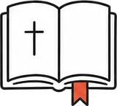 Key words
Word | Meaning
inundation | the Nile’s yearly flood
silt | fine, rich mud left behind by flood water
irrigation | bringing water to crops by canals, ditches or machines
shaduf | a long pole with a bucket and a weight, used to lift water from the river
nilometer | a set of steps or a marked wall used to measure the height of the Nile
delta | the flat, fan-shaped land where a river splits into branches before it reaches the sea
cataract | a stretch of rocks and rapids in a river that boats cannot easily pass
famine | a time when there is not enough food and many people go hungry

Read
Source A: Herodotus, a Greek historian who visited Egypt, writing about 440 BCE (adapted)
The Egypt that the Greeks sail to is land that has been given to the Egyptians by the river. It is the gift of the river.

A green ribbon in the desert
The Nile is the longest river in Africa, about 6650 km long. It flows north from the middle of Africa to the Mediterranean Sea. Almost no rain falls in Egypt. Without the river, the country would be as empty as the Sahara around it. With it, a narrow strip of green runs along each bank, in places only a few kilometres wide.
The Egyptians called their country Kemet, “the black land”, after the dark, rich soil beside the river. The desert was Deshret, “the red land”: hot, dry and dangerous. You could stand with one foot in a green field and the other on bare sand.

The flood that brought life
Every summer, heavy rains fell on the mountains of Ethiopia, far to the south. The water rushed into the Nile, and some weeks later the river in Egypt began to rise. It spread over the fields, then slowly sank back, leaving a fresh layer of black silt. Silt is full of goodness for plants, so every year the river fertilised the fields for free.
The Egyptians shaped their whole year around this flood, the inundation. They had three seasons:
- Akhet, the flood (about June to September): the fields were under water, so many farmers worked on the king’s building projects.
- Peret, the growing season (about October to February): farmers ploughed, sowed and watered their crops.
- Shemu, the harvest (about March to May): crops were cut, threshed and stored, and taxes were paid in grain.
Farmers grew wheat and barley for bread and beer, flax for linen cloth, and onions, beans and lettuce.
Source B: Herodotus, writing about farmers in the north of Egypt (adapted)
These people gather their harvest with less work than anyone else. They do not have to plough or dig. They wait until the river rises by itself and waters their fields, then goes down again. Then each man sows his field, lets his pigs walk over it to tread in the seed, and waits for the harvest.

Catching the water
The flood was not always kind. Too little water meant hungry years and famine. Too much water washed away villages. So the Egyptians measured the river with nilometers: stone staircases or walls going down into the water, marked with levels. Officials used the height of the flood to predict the size of the harvest and to set how much tax each farmer must pay.
Farmers did not just wait for the flood. They built earth banks to divide the land into large basins. When the flood came, water was trapped in each basin and left to soak into the soil for weeks before it was let out. This is called basin irrigation. Canals carried water further from the river.
By New Kingdom times, farmers were also using the shaduf. A long pole rests on a frame, with a bucket on one end and a heavy weight of stone or mud on the other. The farmer pulls the bucket down into the water. The weight then helps him lift it, and he swings it round and empties it into a canal. Shadufs are still used in some places today.
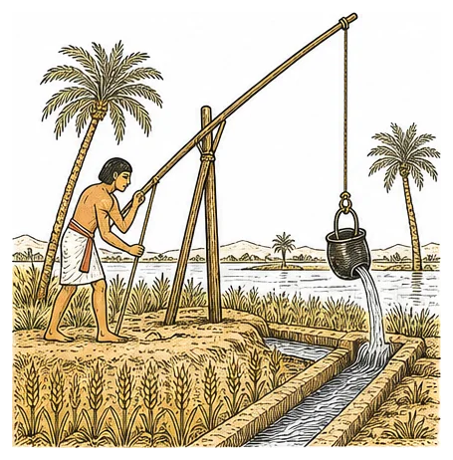
A farmer lifts water from the river with a shaduf.

Walls of sand, a road of water
Egypt’s geography also kept it safe. Deserts lay to the east and west, the sea to the north, and the rocky cataracts of the Nile to the south. Armies found Egypt hard to reach, so for long periods its people could farm and build in peace.
The Nile was also Egypt’s main road. Boats carried grain, cattle, people and huge blocks of stone. Going north was easy, because the current flows north. Going south was easy too, because the wind usually blows from the north, so sailors simply raised their sails.

Two lands become one
The south of Egypt, the long narrow valley, was called Upper Egypt, because it is upriver. The north, where the Nile splits into many branches to form the Delta, was Lower Egypt. About 3100 BCE, a king from the south, remembered as Narmer, united the two lands. From then on, pharaohs called themselves “Lord of the Two Lands”.

 Questions
- Use Source A. What did Herodotus mean when he called Egypt “the gift of the river”?
- Explain the difference between the black land and the red land.
- Copy and complete the table about the three seasons.
Season | Months (about)
Akhet
Peret
Shemu

- Number these events from 1 to 5 to show the order in which they happened each year.
Event
Water soaks into the fields trapped in the basins.
Heavy summer rain falls on the mountains of Ethiopia.
Crops are harvested and taxes are paid in grain.
The Nile rises in Egypt and spreads over the fields.
The water is let out and seeds are sown in the wet silt.

- Explain how a shaduf works. Use the words pole, bucket and weight.
- Why did officials want to know how high the flood was each year?
- Use Source B.
  - According to Herodotus, why was farming easier in Egypt than in other lands?
  - Using what you have read about basins, canals and shadufs, explain why Herodotus may not have told the whole story.
- Give two ways the geography of Egypt helped it.
  - A way it protected Egypt:
  - A way it helped travel and trade:
- Upper Egypt is at the bottom of most maps, and Lower Egypt is at the top. Explain why.

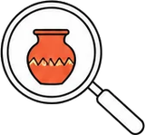 Think like a historian
- “Without the Nile, there would have been no pyramids.” Do you agree? Explain the cause and effect, using two pieces of evidence from the reading.

 Faith connection
“Behold, seven years of great abundance are coming throughout the land of Egypt, but seven years of famine will follow them. Then all the abundance in the land of Egypt will be forgotten, and the famine will devastate the land.” (Genesis 41:29–30)
In Genesis, Pharaoh dreams of seven fat cows eaten by seven thin ones. Joseph, a Hebrew slave who had been put in prison, explains that God is warning Egypt: seven good harvests, then seven years of famine. Joseph advises Pharaoh to store a fifth of the grain in the good years. Pharaoh puts him in charge, and Egypt and its neighbours survive. (Christians and historians date Joseph’s life differently.)
The Egyptians thanked the flood god Hapi for the Nile. The Bible teaches that the one true God made the rivers and sends the rain, and that he gave people the job of caring for the earth (Genesis 2:15). Joseph shows what that looks like: he trusted God, planned wisely and used God’s gifts to keep people alive.
- Joseph’s plan saved lives. Give one way people today can care for rivers, soil or food as gifts from God.

