Reading 1: How do we know about ancient Egypt
Year 7 HASS · Worksheet
Name: ____________________ Date: ______________
Nobody alive today has met an ancient Egyptian, so how can we know anything about them? This reading shows how historians and archaeologists find and read the evidence, and why that evidence needs protecting.

 Key words
Word | Meaning
historian | someone who studies the past, mostly by reading written sources
archaeologist | someone who studies the past by digging up and examining what people left behind
source | anything from the past that gives us information about it
artefact | an object made by people, such as a pot, a tool or a piece of jewellery
papyrus | a kind of paper made from reeds that grew beside the Nile
decipher | to work out the meaning of a code or an unknown writing system
heritage | the places, objects and traditions passed down to us from the past
conserve | to protect and care for something so that it lasts

Read

Detectives of the past
How do we know what the Egyptians ate, how they wrote or what they believed about death? We work like detectives. We collect clues, called sources, and ask careful questions about them.
Two kinds of experts do most of this work. Historians mainly study written sources: letters, laws, prayers, tax records and stories. Archaeologists study what people left behind: buildings, tools, pottery, jewellery, bones and even rubbish. The two work together. A letter tells us what someone said; a broken cooking pot tells us what they actually used.
Egypt is a wonderful place for this kind of work. The desert is so dry that things which rot almost anywhere else, such as wood, cloth, seeds and even bodies, can survive for thousands of years. Many of the best clues come from tombs. The Egyptians filled them with objects for the next life and painted their walls with scenes of farming, feasting and family life.
The Egyptians also wrote a great deal. Scribes wrote on papyrus and carved hieroglyphs into stone. Historians also use other ancient writings, such as the reports of Greek travellers like Herodotus, and the books of the Bible, which mention Egypt many times. Like every source, each one is read carefully and compared with others.

The stone that broke the code
By about 400 CE, the last people who could read hieroglyphs had died out. For more than a thousand years, nobody could read them.
In 1799, French soldiers rebuilding a fort near the town of Rosetta (Rashid), in the Nile Delta, found a broken slab of dark stone. It carried the same message written three times: in hieroglyphs, in demotic (an everyday Egyptian script) and in ancient Greek. Scholars could still read Greek, so now they had a key.
It still took more than 20 years. In 1822, a French scholar named Jean-François Champollion announced that he had cracked the code. He showed that many hieroglyphs stood for sounds, like letters, not just for ideas. Suddenly thousands of inscriptions could be read again. The Rosetta Stone is now in the British Museum in London.
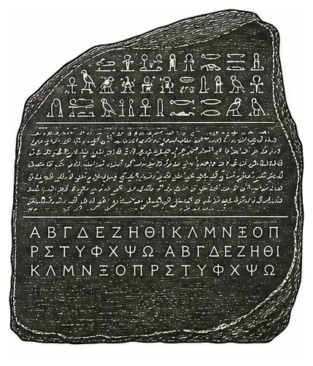
The Rosetta Stone: hieroglyphs at the top, demotic in the middle and Greek at the bottom.

Wonderful things
In November 1922, the British archaeologist Howard Carter was digging in the Valley of the Kings, where many New Kingdom pharaohs were buried. His work was paid for by a rich English lord, Lord Carnarvon. Carter’s workers found a step cut into the rock. It led down to the tomb of Tutankhamun, a young king who had died about 3300 years earlier. Peering in by candlelight, Carter later wrote, he could see “wonderful things”. The tomb held more than 5000 objects, including chariots, beds, jewellery and the famous gold mask.
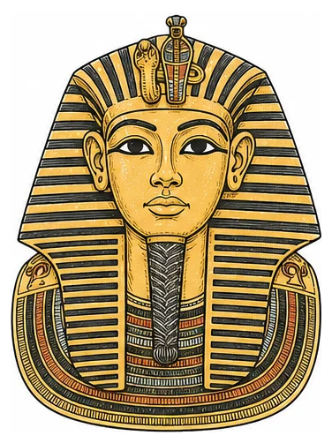
Tutankhamun’s gold funeral mask.

Looking inside without unwrapping
Early explorers often unwrapped mummies, which destroyed them. Today scientists use CT scanners, the same machines hospitals use, to see through the bandages without touching them. When Tutankhamun’s mummy was scanned in 2005, it showed that he was about 19 when he died and that he had a badly broken leg.

Protecting the past
Egypt’s heritage faces many threats. In ancient times, robbers broke into almost every royal tomb looking for gold. Even Tutankhamun’s tomb was robbed soon after his burial, then sealed again. Today, thieves still dig illegally and sell objects overseas. When an object is ripped out of the ground, the clues about where and how it lay are lost forever.
Even visitors can do harm. Thousands of tourists breathe and sweat inside small painted tombs every day. This raises the humidity (the amount of water in the air), which makes paint flake and mould grow. To protect the real tomb, an exact full-size copy of Tutankhamun’s burial chamber has been made nearby for visitors.
To conserve heritage is to care for these places so that people in the future can still learn from them. It matters because the past cannot be replaced: when a painting crumbles, its story goes with it.

 Questions
- What is the difference between a historian and an archaeologist?

- Why have so many objects from ancient Egypt survived for thousands of years?

- Complete the table about the Rosetta Stone.
Question | Answer
When was it found?
Where was it found?
What three scripts are on it?
Who deciphered hieroglyphs, and in what year?

- Why was the Greek writing on the Rosetta Stone the key to reading hieroglyphs?

- Write true or false. If a statement is false, correct it.
Statement | True or false | Correction (if false)
Tutankhamun’s tomb had never been touched by robbers before 1922.
A CT scan lets scientists see inside a mummy without unwrapping it.
People have been able to read hieroglyphs without a break since ancient times.

- Name three threats to Egypt’s heritage. For each one, explain how it does damage.
Threat | How it does damage

- A looter digs up a beautiful statue and sells it to a collector, who keeps it safe in a glass case. Explain why historians still say important evidence has been lost.

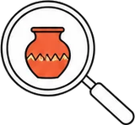 Think like a historian
- Tutankhamun’s tomb is one of the richest finds ever made. How useful is it for learning about the lives of ordinary Egyptian farmers? Give one thing it can tell us and one thing it cannot.

 Faith connection
“In the future, when your children ask, ‘What do these stones mean to you?’ you are to tell them, ‘The waters of the Jordan were cut off before the ark of the covenant of the LORD. When it crossed the Jordan, the waters were cut off.’ Therefore these stones will be a memorial to the Israelites forever.” (Joshua 4:6–7)
When Israel crossed the Jordan River into the promised land, God told Joshua to set up twelve stones from the riverbed. The stones were a kind of heritage site. They were meant to make children ask questions, so that parents could tell them what God had done. The Bible often asks God’s people to remember and pass on the story: “One generation will commend Your works to the next” (Psalm 145:4).
The past matters to Christians because their faith rests on things that really happened in real places, above all the life, death and rising again of Jesus. Christians believe God acts in history. Caring for the past, telling it truthfully and handing it on are ways of honouring him and loving the people who will come after us.
- Joshua’s stones were set up so that children would ask a question. Name something in your family, church or community that helps people remember the past. What does it help them remember?

- Why do you think the past matters to Christians? Use the reading in your answer.

